**Quantify the Impact of the Ultra Low Emission Zone on Footfall Patterns in High Streets and Social Equality across London**

An Interrupted Time Series Analysis on Spatial Units

Xinyu Wu

22 August 2024

CASA0010 for MSc Dissertation

Supervised by Dr Chen Zhong and Yikang Wang

Word Count: 11065

This dissertation is submitted in part requirement for the MSc in the Centre for Advanced Spatial Analysis, Bartlett Faculty of the Build Environment, UCL.

# Abstract

As a crucial element of the economic and social structure of urban areas, high streets especially those in Outer London are declining. To address the challenges of high streets’ revitalization and town centre vibrancy enhancement in Outer London, as well as to explore the potential impact of the Ultra Low Emission Zone (ULEZ) expansion on the local economy, this research investigated three key areas. First, it quantified the causal impact of the ULEZ expansion on visitor patterns in Outer London. Second, it examined the policy's effects on social equality. Lastly, it explored the socio-spatial heterogeneity of these impacts. Using the Spatially Robust Interrupted Time Series (SRITS) method, an adaptation of Zhang and Ning’s SITS design, the study effectively controlled for seasonal trends and analysed how the social and spatial characteristics of different high streets shaped their response to ULEZ. The results show that the ULEZ expansion did increase footfall on local high streets, particularly in deprived areas, where the policy intensified the reliance on nearby high streets. Additionally, the study found that the composition and size of high streets play a crucial role in their vitality. These findings underscore the importance of supporting local businesses in Outer London, especially in disadvantaged areas, and provide strategic insights for post-ULEZ high street development.

# Table of Contents

Abstract 1

Table of Contents 2

List of Figures 3

List of Tables 4

Chapter 1 Introduction 6

Chapter 2 Literature Review 9

2.1 The Ultra Low Emission Zone 9

2.2 High Street Vitality 10

2.3 Social Inequality in Mobility Policy 11

2.4 Research Aim 12

Chapter 3 Study Area and Data Description 14

3.1 Study Area 14

3.2 Data Source 17

3.3 Statement of Ethics 20

Chapter 4 Methodology 21

4.1 Spatially Robust Interrupted Time Series (SRITS) 21

4.2 Analytical Stages and Model 24

4.2.1 Level 1 Model Specification 25

4.2.2 Level 2 Model Specification 26

4.3 Data Preparation 28

4.3.1 Workflow 28

4.3.2 Data Cleaning 29

4.3.3 Matching Control Groups 29

4.3.4 Building Socio-spatial Profiles for High Streets 32

Chapter 5 Results 33

5.1 Temporal Heterogeneity in Policy Effects 33

5.2 Socio-spatial Heterogeneity in Baseline Footfall (P = 0) 36

5.3 Socio-spatial Heterogeneities in Gradual Policy Effects (P = 14) 37

5.4 Socio-spatial Heterogeneities in Gradual Policy Effects (P = 6) 39

Chapter 6 Discussion 41

6.1 How does ULEZ affect the Vitality of High Streets? 41

6.2 How does ULEZ affect inequality in Outer London? 41

6.3 Demand for Outer London 42

6.4 limitations 43

Chapter 7 Conclusion 44

Acknowledge 45

Bibliography 46

# List of Figures

Figure 1.1 Timeline of Transport-Relevant Policies (Data sourced from: Mayor of London, 2023; the C40 Knowledge Hub, 2019; Institute for Government Analysis, 2022) 6

Figure 1.2 Different Phases of Ultra Low Emission Zone Map (Map sourced from: Mayor of London, 2022) 7

Figure 3.1 Map of High Streets with LSOA level Index of Multiple Deprivation 15

Figure 3.2 Study Period with Timeline of Transport-Relevant Policies (Data sourced from: Mayor of London, 2023; the C40 Knowledge Hub, 2019; Institute for Government Analysis, 2022) 16

Figure 3.3 Averaged Daily Footfall Counts of All High Streets in Outer London 18

Figure 4.1 Interrupted Time Series Design with Model Coefficients (Image sourced from: Warton, 2020) 23

Figure 4.2 Framework of Data Processing Stage 28

Figure 4.3 Segmented Regression Plot of Manor Road High Street 30

Figure 4.4 Segmented Regression Plot of Bridge Road High Street 31

Figure 5.1 Map of Visitor Baseline Level in Each High Street Pre-ULEZ 37

Figure 5.2 Map of Gradual Visitor Change in Each High Street Post-ULEZ 39

Figure 5.3 Map of Abrupt Visitor Change in Each High Street on ULEZ Expansion Date 40

# List of Tables

Table 3.1 Data Source and Description 17

Table 5.1 Full Estimates of the Spatially Robust Interrupted Time-series Model 33

# Declaration

I, Xinyu Wu, hereby declare that this dissertation is all my own original work and that all sources have been acknowledged. It is 11065 words in length.



# Introduction

According to the World Health Organization (WHO), air pollution currently poses the greatest global environmental health risk. To tackle the increasing concerns about air pollution and its impacts on public health and ecological systems, many cities are adopting transport policies that consider vehicle emission levels as a common strategy (Prieto-Rodriguez et al., 2022), for example, low emission zone (LEZ) policies have been implemented mostly in Europe when there were 228 of them in 2022 (Filip and Veronika, 2024), including Madrid (Peters, Burguillo and Arranz, 2021), Paris (Poulhès and Proulhac, 2021), etc. London is no exception. As reported by the Greater London Authority (2020), exposure to elevated levels of air pollutants results in the premature deaths of thousands of Londoners annually. Recognising the significance of maintaining a clean air environment and managing road traffic, London has effectively implemented several policies. These include the Congestion Charge Zone in 2003, the Low Emission Zone in 2008, the Toxicity Charge in 2017, and the Ultra Low Emission Zone in 2019 (the C40 Knowledge Hub, 2019), as shown in Figure 1.1.

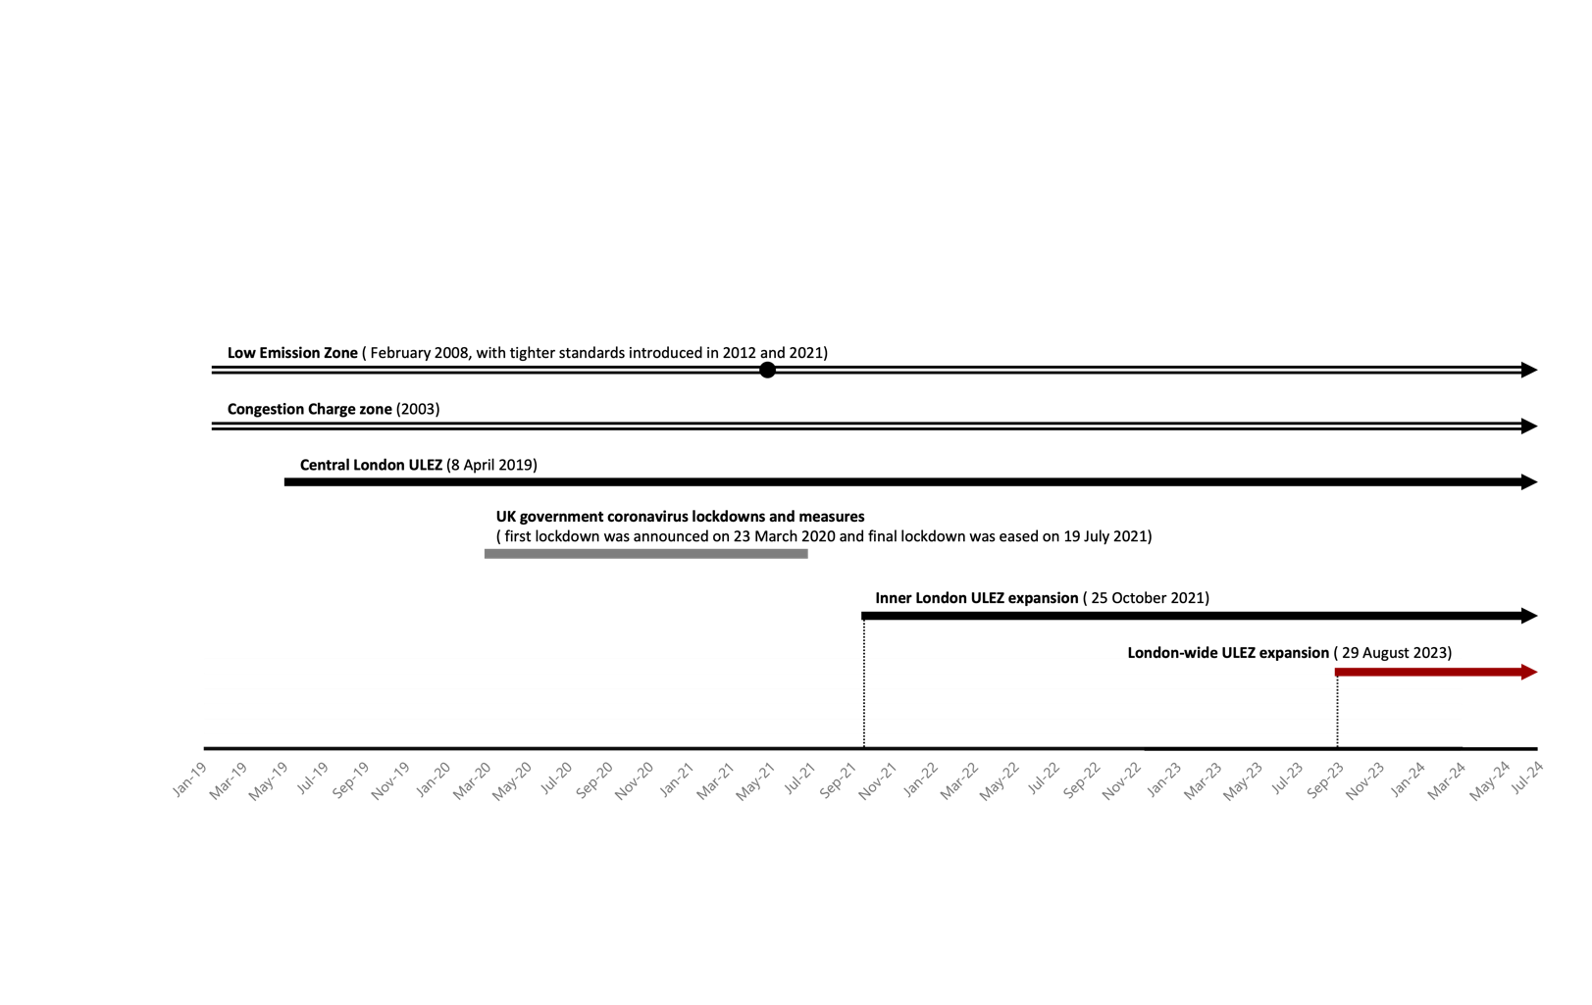

Figure 1.1 Timeline of Transport-Relevant Policies (Data sourced from: Mayor of London, 2023; the C40 Knowledge Hub, 2019; Institute for Government Analysis, 2022)

This research aims to analyse the second expansion of ULEZ in London. The Ultra Low Emission Zone (ULEZ) was initially launched on 8 April 2019 towards Central London, with two expansions on 25 October 2021 towards Inner London and 29 August 2023 towards most of Outer London, address the critical issue of harmful air pollution emissions from road transport, as illustrated in Figure 1.2.

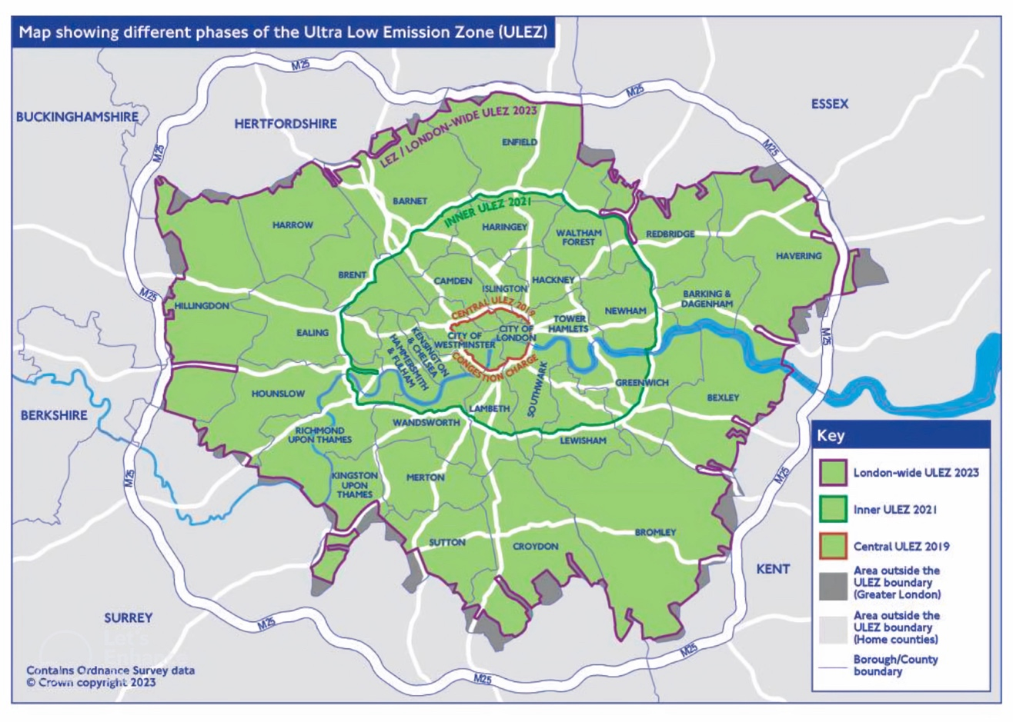

Figure 1.2 Different Phases of Ultra Low Emission Zone Map (Map sourced from: Mayor of London, 2022)

When the second expansion of the Ultra Low Emission Zone (ULEZ) extended its boundaries to include most of Outer London, this area was simultaneously grappling with its distinct socio-economic challenges. Boris Johnson’s 2008 mayoral campaign team highlighted that the needs of Outer London’s suburban areas, home to a significant portion of the city’s population, had been largely overlooked, a point noted by Williams (2020). The enthusiasm for developing Outer London peaked with the release of the 2016 London Plan. The ULEZ was proposed as part of the broader strategic planning framework outlined in the 2016 London Plan, which was released in March 2016 by the Mayor of London and provides valuable guidance for shaping the future of neighbourhoods through socio-environmental dimensions, including economic development and transportation (Mayor of London, 2016). The London Plan initiated the Outer London Commission to “identify economic, social, and environmental benefits that could be realised” in Outer London, aiming to redress its long-neglected economic performance. The Plan now provides guidance focusing on rejuvenating the local economy, enhancing the vibrancy of town centres, and identifying and alleviating pockets of deprivation as key economic strategies for Outer London.

Amid ongoing economic and cultural shifts in society, town centres and high streets across the UK are undergoing a significant transformation. In Britain, the term “High Street” is typically characterised as the main commercial street (or streets) within towns or cities, commonly viewed as a town or city centre location and a hub for shops and retail activities. High streets are essentially mixed-use urban corridors, linked to town centres but frequently extending beyond town centre boundaries (Carmona, 2015). According to Griffiths *et al.* (2008), the term “high street” evokes images of comfortably small town or suburban neighbourhoods marked by social stability and a lasting local identity where residents socialize and gain everyday goods. However, due to rising car ownership, the growth of online shopping, and changing lifestyles, high streets today are increasingly facing challenges to their vitality and viability (Griffiths *et al.*, 2008; Parker *et al.*, 2016).

Given the crucial role that high streets play in the economic and social fabric of urban areas, it is vital to examine the impact of the Ultra Low Emission Zone on the performance of Outer London’s high streets. This analysis will not only respond to the 2016 London Plan’s guidance on economic development in Outer London by identifying the ULEZ impact on town centres’ vibrancy and uncovering the deprivation but will also help in understanding the broader implications for local economies and businesses, providing direction for future policy formulation for local business.

Against this backdrop, this paper sets out to investigate the causal impact of the second expansion of the Ultra Low Emission Zone on the vitality of Outer London’s high streets. Consequently, the primary research question guiding this study is:

*How does the second expansion of the ULEZ causally affect the vitality of Outer London’s high streets?*

Initially, this paper aims to quantify the effects of the second expansion of ULEZ on the rejuvenation of the local economy, specifically examining whether the vitality of high streets has increased or decreased in Outer London. Subsequently, the research will explore how these effects vary between the geographic hierarchy of different socio-economic components and built environment features. Ultimately, by analysing how the policy impacts various spatial units differently, this study wants to reveal whether inequity is exacerbated or attenuated because of the expansion of ULEZ, such as unintentionally favours more affluent regions or effectively supports economically disadvantaged areas.

# Literature Review

This chapter primarily intersects with three distinct areas of literature. The first area includes studies conducted by previous researchers that have examined the impact of ULEZ. The second area focuses on the vitality of high streets. The third area involves research into policy inequity. Finally, this chapter summarizes the research gap and outlines the significance of this study within the field.

## The Ultra Low Emission Zone

In terms of the causal impact of the Ultra Low Emission Zone in London, numerous studies have been conducted. Most previous research concerning the ULEZ or related transport policies primarily concentrates on the policy’s primary objective: reducing air pollution and the resultant health benefits for residents. For instance, Zhai and Wolff (2021) quantified the effectiveness of London’s LEZ in reducing its target pollutant, PM10 and the reasons behind the disparity which is the changes in traffic volume. Prieto-Rodriguez et al. (2022) carried out a quantitative analysis to assess the effectiveness of the ULEZ in reducing NO₂ levels. It has also been proven that the implementation of ULEZ can encourage the transition to green transportation modes, stimulating the bicycle demand within the zone (Ding et al., 2023). The findings of these studies are derived from causal inference methods, predominantly Difference-in-Differences (Diff-in-Diff) models, an empirical approach that is widely utilized in public health research and intervention analysis.

While researchers pay more attention to the above topics, the economic impact of the policy has acquired little attention to examine and is not based on causal inference methods. Among the limited studies available, most have examined the macroeconomic effects of ULEZ, such as the overall socioeconomic growth resulting from cleaner air and the living costs associated with ULEZ’s charging regulations. Specifically, it is reported that improvements in NO₂ levels due to ULEZ are expected to extend the life expectancy of future Londoners, potentially generating an estimated £800 million in economic benefits (Jansen, 2021). Additionally, some researchers have identified significant potential costs for small businesses and residents living within or near the restricted zone’s boundary, as their lives rely on light goods vehicles and cars, which are strictly regulated (GREATER LONDON AUTHORITY, 2017).

Researchers have rarely focused on the economic impact of ULEZ from the performance of high streets and the perspective of consumer behaviour. Kieran Taylor (2020) documented for the Lambeth Council that interventions like the Streatham Hill Low Traffic Neighbourhood have demonstrated a reduction in traffic, which can enhance business footfall. This is achieved by creating a more appealing street environment and providing additional physical space for operations, thereby attracting more customers and potentially boosting retail sales. It is noted by some European cities. Navrátil and Gežík (2024) have once investigated the effects of LEZ on the standard retail operations and consumer behaviour in Madrid Central by surveying retailers and consumers. Their findings indicate that 38.17% of people believe that, restricting access to car traffic could diminish their inclination to shop in the city centre, indirectly leading to a decline in the sales of shops in the centre, while 34.92% of respondents believe that their shopping activity will be increased due to the safer and cleaner road environment. This survey result is ambiguous and may be attributed to potential social desirability bias in its methodology. This bias occurs when respondents answer questions in ways they consider socially acceptable, rather than reflecting their true feelings or behaviours.

## High Street Vitality

Many high streets in the UK are experiencing a decline due to the rapid development of technology and social change, and outbreak of the COVID-19, with more than 17,500 chain stores and other venues closing across Great Britain, and footfall declining by over 80% (Wang, Zhang and Cheng, 2023). Yet they continue to be the psychological heart of the community and present a unique opportunity for intervention. Properly addressing these areas could catalyze broader regeneration, potentially benefiting the entire community (Williams, 2020). Therefore, given this backdrop, the revitalization of high streets is a pressing necessity and numerous studies have been conducted under such a severe situation.

Although the performance of town centres involves intricate and multifaceted concepts, there are still some measurements that can capture the dynamic activity in high streets and serve as a dependable surrogate for evaluating performance in current studies. As Parker et al. (2016) note, footfall serves as – to use the Department for Business Innovation & Skills’s (Department for Business, Innovation and Skills, 2011) terminology – a metric for gauging the vitality of a commercial centre or high street and acts as an indicator of potential consumer spending. It is also acknowledged in policy and planning as a crucial indicator of a town centre’s vitality and viability (DoE, 1996, as cited in Mumford *et al.*, 2021). Thus, footfall data serves as a valuable tool for assessing how the introduction of mobility policies by governments, aimed at restricting high-emission vehicles, has altered daily activity patterns.

It is proved that footfall patterns are shaped by a variety of factors across different levels: at the national level, by government policies; at the town centre level, by pre-existing trends, characteristics of the town centres, and seasonal effects; and at the personal level, by demographic profiles and individual experiences (Enoch *et al.*, 2022). Enoch *et al.* have observed the impact of the first wave of coronavirus on town centre activity, specifically the footfall recovery rate. Their findings suggest that differences in population profiles and scale of town centres may be factors influencing footfall resilience, though no clear connection with levels of deprivation was observed. Wang, Zhang and Cheng (2023) found the resilient performance of high streets after the pandemic varies between regions, where those located in the suburb recovered better, showing the spatial heterogeneities among policy effectiveness. They also highlighted the importance of community engagement in the recovery of high streets. Also to support urban regeneration, Parker et al. classified the top 25 prioritized factors to improve the vitality and viability of high streets (2016), where necessities, place marketing and entertainment, etc. are among indicators that have the most impact on high street’s vitality and viability. Emergent critical literature has focused on understanding the dynamic activity of high streets after interventions, but no transport policy has been explored under this context.

Along similar lines, this paper views footfall as a key measure of high street vitality and, consequently, an indicator of the impact of ULEZ policy. The objective is to investigate how footfall can provide insights into the varied responses of high streets to changes instigated by mobility policy and to assist society and policymakers in understanding the operational outcomes of ULEZ.

## Social Inequality in Mobility Policy

It is found that early in the 2000s, UK academics and policymakers started exploring the relationships that policy between poverty, transport disadvantage and social exclusion (Lucas, 2012). Numerous studies have highlighted how transport and spatial disadvantages collectively reinforce social inequality. For example, situations like road deaths and air pollution that happen to deprived groups, which are brought by living near busy roads and having non-car-based travel patterns, can be interpreted as social inequality (Titheridge *et al.*, 2014). More studies proved that European LEZs policy does not benefit the poorest neighbourhoods as they are commonly found near freeway rings which are the most polluted areas (Charleux, 2014). This highlights the social inequality exacerbated by mobility policies due to the existing spatial disadvantages.

In addition to worsening existing social inequalities by reinforcing spatial disadvantages, traffic restriction policies can also exacerbate transport disadvantages, further deepening social inequality. For example, research has found that LEZ policy appears to be associated with higher proportions of non-compliant vehicles in lower-income areas (Verbeek and Hincks, 2022), where paying fines for non-compliant vehicles or replacing vehicles inadvertently increases the financial burden on deprived communities. According to Farrington (2007), if a person or household is not able to use their car due to limited accessibility brought by mobility restrictions, their levels of life opportunities are constrained consequently, potentially hindering social equality. In addition to the negative impacts mentioned above, these policies can also have positive effects. According to Gorman et al. (2003), the promotion of sustainable modes of transportation from Edinburgh’s transport policy is advantageous in reducing health-related inequalities.​ While many studies of LEZs, little is known about the impacts of ULEZs on mobility behaviour and possible social differentiations.

It is evident that increasing car ability in the UK has allowed citizens to travel far greater distances and supports more activities. However, this situation discouraged the viability of other transport modes and played a role in the inequality of already deprived groups in the UK population (Lucas, 2012; Lucas, 2006). Inequality exists not only between car owners and non-car owners but also within the car-owning group itself. The 2010 UK National Travel Survey (NTS) identifies that 53% of households in the highest income quintile owned two or more cars, while only 12% of households in the lowest income quintile had the same level of car ownership, also demonstrating an obvious private transport disadvantage in lower income groups. Thus, it is worth exploring the inequality change after the implementation of ULEZ.

Overall, it is unjust to deprive residents of the ability to drive to essential services located far away, without providing viable local businesses within accessible distances on nearby high streets. As in global initiatives such as the Sustainable Development Goals, Habitat III, C40 Cities, United Cities and Local Governments, and WHO Healthy Cities, urban equity has become a policy priority for many cities worldwide (Suel *et al.*, 2024). Ensuring equal opportunities and reducing the inequalities caused by discriminatory policies are also key objectives of the 2030 Agenda for Sustainable Development. In this context, it is essential to assess whether the inequitable conditions in deprived areas of Outer London have been exacerbated or alleviated. Identifying variations in policy effects can highlight the disproportionate burdens faced by disadvantaged groups, thereby helping to address social equity issues (Gozzi *et al.*, 2021).

## Research Aim

To conclude, while there are studies demonstrating the economic impact of ULEZ, most are conducted at a macro level like country or city and incorporate minimal data from the town centre or high street level. Research specifically examining the causal impact of ULEZ on high street vitality in London is virtually nonexistent. What’s more, to date no studies of ULEZ have been conducted that isolate the magnitude of the effect from other relevant factors. Meanwhile, ULEZ serves as an ideal research object when exploring how a complex decision-making system plans daily schedules and activities within a socio-spatial constraint (Gärling *et al.*, 1998) since residents’ travel behaviour shifts with this policy varies in each household due to their different conditions (Burrough and McDonnell, 1993). Therefore, in accordance with the strategic plan in the 2016 London Plan, the vital role of high streets and the importance of revealing inequalities in the UK, the heterogeneous effect of London-wide ULEZ on the vitality of different high streets merits further investigation.

In this context, this paper aims to address these research gaps, giving a first exploration of the inference of both the temporal pattern of and spatial contextual effects on the treatment effects of ULEZ, and providing policymakers with reliable suggestions based on empirical experiments to enhance high street vitality and neighbourhood equity in Outer London. To be specific, this study aims to investigate the spatiotemporal heterogeneity in the causal effectiveness of ULEZ interventions, focusing on fine-grained spatial units, such as high streets, and detailed time-series intervals.

# Study Area and Data Description

This brief section provides a description of the study area and the datasets involved in this research. This review offers background information that is useful for understanding the methodology described in the following chapter.

## Study Area

According to the first-month report of London-wide ULEZ by the Mayor of London (2023), most vehicles (including cars, vans, motorcycles, mopeds, and so on) driving in the regulated zones have to either satisfy strict emissions criteria or be charged £12.50 per day. The current ULEZ covers the London-wide area and operates 24 hours a day, every day of the year except Christmas Day (Mayor of London, 2023), which strongly incentivises people to change their driving behaviours into a more sustainable and eco-friendly mode. It is worth noting that, during the first month after the second expansion of ULEZ, the compliance rate for vehicles that met the ULEZ standards London-wide shows a 3.7 per cent increase from 91.6 per cent in June 2023 (Mayor of London, 2023), which is a lighter shift compared to a 6.7 per cent increase after the second expansion.

To specifically isolate the impact of ULEZ on footfall in Outer London’s high streets, all the data will be clipped and aggregated on the corresponding high streets. The study area is 419 high streets in Outer London within the second expansion area of ULEZ, shown in Figure 3.1 by yellow areas. It can be seen clearly that high streets are urban corridors, stretching for many miles along key routes through urban areas (Carmona, 2015). By Carmona’s detailed research, high streets are identified into several morphological characteristics, including connected high streets, isolated high streets, clustered high streets, etc. The almost continuously connected high streets are grown alongside the main roads, while the presence of these smaller, isolated high streets is largely attributed to the polycentric nature of London. Each high street has its unique growth environment, collectively contributing to the complex and vibrant landscape of London's high streets.

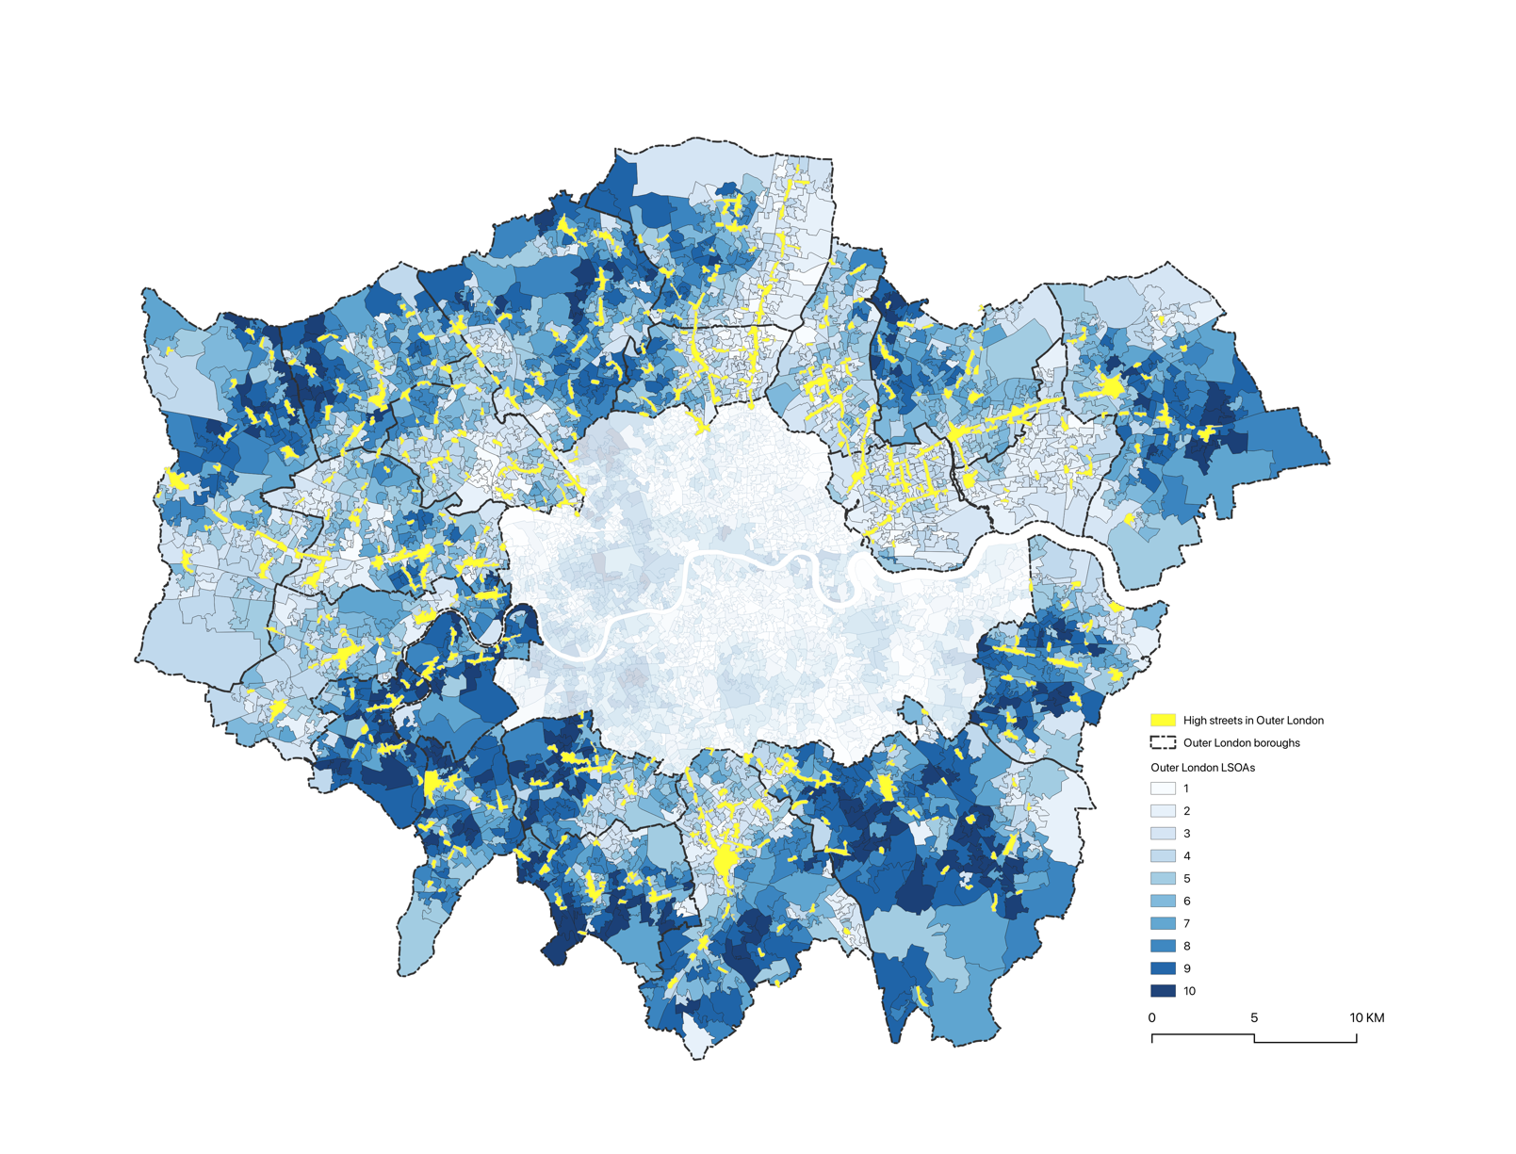

Figure 3.1 Map of High Streets with LSOA level Index of Multiple Deprivation

As noted by the one-year report on the Inner London Ultra Low Emission Zone (2023), the traffic level of outer London has primarily rebounded to the pre-pandemic level. The whole period of the study will be after the COVID restrictions ended on 19 July 2021 (Institute for Government, 2022) to avoid being affected by it. which has no concurrent policies as shown in Figure 3.2. Additionally, the power of ITS increases when the size of sample or effect size increases, as well as using balanced numbers of study periods pre- and postintervention (Zhang, Wagner and Ross-Degnan, 2011). It is also suggested that daily data involving at least 24 data points (12 before and 12 after the intervention) be used to make the power estimates reliable (Zhang, Wagner and Ross-Degnan, 2011; Dorais, 2024). Thus, to effectively capture the summer trend observed in Figure 3.1 and ensure the reliability of the model, this paper will utilise 8 weeks of daily data points from both before and after the intervention of the second expansion of ULEZ, which took place on August 29th, 2023, which is 16 weeks for the whole study period. The study period is illustrated in Figure 3.3. This approach also helps the study avoid unnecessary impacts from other transportation policies, as the ITS method struggles to differentiate between multiple events (Zhang and Ning, 2023; A Guide on Data Analysis, 2024).

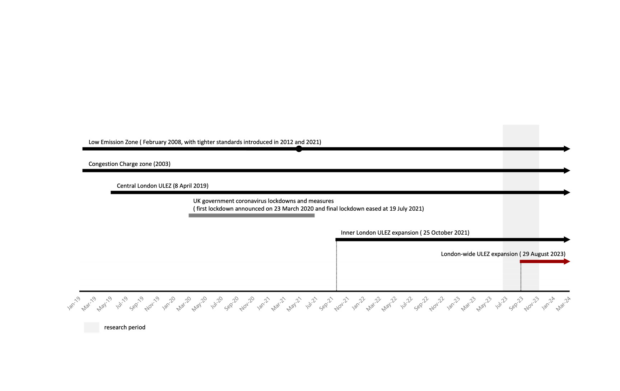

Figure 3.2 Study Period with Timeline of Transport-Relevant Policies (Data sourced from: Mayor of London, 2023; the C40 Knowledge Hub, 2019; Institute for Government Analysis, 2022)

It is said that 69% of households own a car in outer London, compared to 42% in inner London (Mahmud, Cottell and Harding, 2023). The National Travel Survey England 2022 Main Results noted that the most common trip purpose in 2022 was shopping, with 18% of journeys being made for this purpose (Department of Travel, 2023). Barton, Horswell, and Millar (2012) also observed that according to the European Environment Agency, residents living especially in the peripheral, less dense areas of towns and cities tend to drive to distant, larger facilities rather than using sustainable transport methods to access closer, smaller amenities, indicating that residents of outer London are likely significantly affected by the ULEZ traffic restrictions. Meanwhile, it is widely agreed that a model shift is made by London’s emission zone policies and more trips feature active travel which is walking, cycling and public transport (Union of Concerned Scientists, 2024), efficiently encouraging people to decrease the usage of vehicles. Thus, this paper hypothesizes that the footfall patterns of residents in Outer London are likely to shift due to the intervention of the second expansion of the ULEZ. Specifically, it is anticipated that the lifestyle of driving to distant facilities will be supplanted by visits to nearby local high streets. Consequently, this will lead to increased pedestrian activity and enhanced vitality on local high streets due to restrictions on car usage. Given this hypothesis, the relevant datasets will be considered and collected in the following section.

## Data Source

This study utilizes fine-grained spatial and temporal data, enhancing the ability to discern spatiotemporal heterogeneity in the causal effects of ULEZ intervention. As illustrated in Table 3.1, this research is supported by five datasets under two main aspects, high street mobility data and socio-economic data. The footfall data capture temporal heterogeneity, while indices of deprivation, premises data and geographic data address socio-spatial and spatial heterogeneities, respectively.

Table 3.1 Data Source and Description

|  |  |  |  |
| --- | --- | --- | --- |
| **Theme** | **Datasets** | **Geography / Time fineness** | **Context** |
| High Street Data | Mobility Data (BT) | 350m hex level / in each 3-hour period daily | Visitors, workers, residents |
| Socio-spatial Data | English Indices of Deprivation 2019 (IMD) | LSOA level | Index of Multiple Deprivation (IMD) |
| Premises Data (Experian) | Shop point with Goad location | Retail category |
| Geographic Data | High Street Boundaries | / | / |
| Lower Super Output Area (LSOA) 2021 | / | / |

Footfall data is the primary data of this research and was obtained from the Greater London Authority (GLA). The Footfall Data, provided by the data supplier British Telecom (BT), aggregates and anonymizes the number of individuals present in each hex grid across London for each 3-hour interval daily. This dataset only includes counts of people who spend more than 10 minutes within a specific hex, a system developed by Transport for London. It encompasses 15,042 hexagons, covering the entirety of London, with each hexagon measuring 350 meters across. I spatially selected 12,255 hexagons within Outer London, which is delineated by the 419 high streets in Outer London, excluding those that fall outside the boundary of the second expansion of the ULEZ. This selection captures counts of three types of footfalls. These three footfall categories represent the number of residents, workers, and visitors who spend more than 10 minutes in a specific hex within a given period, with residents primarily present during the evening and night, workers during their working hours, and visitors being non-residents and non-workers.

As this study focuses on high street vitality, I specifically extracted data on visitors to investigate pedestrian volume on high streets. Figure 3.3 is created by aggregating all the footfall counts throughout each day to obtain the daily 3-hour footfall counts of hexagons in Outer London. A clear seasonal trend is evident, with noticeable drops in footfall during the summer months of both years, likely due to holiday absence (Lai *et al.*, 2022).



Figure 3.3 Averaged Daily Footfall Counts of All High Streets in Outer London

As Dorais (2024) said in his paper, descriptive modelling can help with explaining trends, cycles, and seasonal patterns within the data. To identify the factors contributing to seasonality in visitor footfall, I isolated the trend, seasonality, and noise from the chronological footfall data by specifying a commonly occurring seasonal period—a day. This allowed a clear weekly trend to emerge, as shown in Figure 3.4. It covers 6 weeks total, 3 weeks each before and after the ULEZ intervention. The third figure in Figure 3.4 illustrates a significant variation in how footfall is spread out over the week, with Saturday and Sunday clearly gaining a lot of weekly footfall volume compared to the weekdays in high streets within Outer London (Friday, September 1, 2023, serves as a reference point). This pattern suggests that the majority of people in Outer London visit high streets on weekends, implying that these visits are largely driven by leisure activities.

Figure 3.4 Time Series Components of Mean Daily Visitor Counts of All High Streets in Outer London

To figure out the socio-spatial features underlying the impact of ULEZ, the English Indices of Deprivation 2019 and Premises Data were chosen for the second-level model. The former dataset contains the Index of Multiple Deprivation (IMD), a comprehensive measure of relative deprivation, constructed by combining seven domains of deprivation, each weighted accordingly. Specifically, these domains include income deprivation, education deprivation, health deprivation and disability, crime deprivation, employment deprivation, barriers to housing and services, and living environment deprivation. It is a comprehensive dataset used to measure and compare levels of deprivation across LSOAs in England. The latter one, the premises dataset includes shop locations and their retail information, which is sourced from Experian's Business Data.

The additional datasets of geo-features encompass two levels of spatial units, which are the high street boundaries, developed by the Regeneration team at the Greater London Authority, and the Lower Super Output Area (LSOA) data downloaded from the London Datastore, corresponding to the smallest spatial units of socio-economic features.

## Statement of Ethics

The footfall and premises data, included in BT's Geolocated Mobile Network Data, are owned by the Greater London Authority (GLA) and have been made available through a HIGH STREETS DATA SERVICE Contractor Sub-License. All other data used in this study is publicly accessible online. The data involved in this research has been aggregated and anonymized and is used solely to analyse the causal impact of the ULEZ in Outer London. The study does not aim to reveal any private individual information. Although the footfall and premises data are provided at a fine-grained spatial level, low numbers in the footfall data are suppressed as part of the anonymisation process to ensure privacy.

# Methodology

This section begins by providing an explanation of the methodological approach and model specification, which is the Spatially Robust Interrupted Time-Series (SRITS) quasi-experimental design developed in this paper. This design builds upon the Robust ITS (RITS) design and the existing Spatially Interrupted Time Series (SITS) methodologies from previous research. Additionally, it outlines the data preparation workflow for the two-level causal inference model, detailing the steps involved in data processing, data cleaning, and the subsequent analysis. Through this discussion, the chapter aims to clarify how the SRITS framework is applied to investigate the causal impacts of ULEZ on Outer London high streets, emphasizing the integration of both temporal and spatial dimensions in the analysis.

## Spatially Robust Interrupted Time Series (SRITS)

In this paper, a Spatially Robust Interrupted Time-Series (SRITS) method is developed and modified based on the Spatially Interrupted Time Series (SITS) from Zhang and Ning (2023). SRITS aims to evaluate the causal influences of ULEZ on footfall patterns, with which the effects of confounding factors – socio-economic components – will be accounted for.

The initial SITS is a quasi-experimental design developed by Zhang and Ning (2023) based on a single Interrupted time series (ITS) to causally infer the spatiotemporal heterogeneities in the mobility control policies’ effects, whose application is historically sparse across mobility policy research and is a methodological innovation. Single ITS is widely adopted in public health and road safety (Lopez Bernal, Cummins and Gasparrini, 2016; Abegaz et al., 2014; Warton, 2020) due to its advantage of no need for a comparison group to detect temporal patterns in a series of chronological data points. ITS works by effectively estimating the counterfactuals through the pre-intervention series (Zhang and Ning, 2023). However, ITS is likely to be affected by time-varying confounders, such as other events or cyclical trends when the data doesn’t contain enough cycles, which causes the issue of poor internal validity (Lopez Bernal, Cummins and Gasparrini, 2018; Warton, 2020). Poor internal validity is particularly problematic when the data does not cover enough cycles (Warton, 2020), or exhibit a long and stable pre-intervention trend unless it resembles cases like the per-capita travel distance in Shenzhen before the first-level response to public health emergencies (Zhang and Ning, 2023), which supports the credibility of the counterfactual.

To address the issue of poor internal validity occurring in experiments using a single ITS, instead of relying on the single ITS, this research employs a Robust ITS design (Warton, 2020), also referred to as multiple-group ITS (Linden, 2015), or controlled (or comparative) interrupted time series (CITS) analysis (Lopez Bernal, Cummins and Gasparrini, 2018). Robust ITS is an efficient way to minimize potential confounding from coinstantaneous events by including a control group (Lopez Bernal, Cummins and Gasparrini, 2018). Comparing the outcomes of the treatment group with one or more control groups naturally enhances internal validity, enabling the researcher to more effectively manage potential confounding variables that might otherwise be missed (Linden, 2015). Therefore, considering the obvious annually seasonal trend, as shown in Figure 3.1, in footfall data from 2022 to 2023, it is vital to have a comparable comparison between control and treatment groups in this research, leading me to use a Robust ITS design.

Similar to the Difference-in-Differences (D-I-D) method which is also a robust quasi-experimental design widely utilized to evaluate the effects of policy interventions (Wysling and Purves, 2022). RITS and D-I-D are both being modelled based on time-series data with an unexposed group. However, RITS can evaluate both the value of the sudden level change at the interruption as well as the slope difference before and after the interruption, rather than D-I-D focusing on measuring only the difference in means between groups (Warton, 2020), which enhances the practical relevance of policy effect estimation. The equation for the Robust ITS model includes all the coefficients from Figure 4.1 as below:

$$μ_{t}= β_{0}+ β_{1}* {Time}_{t}+ β_{2}*{Intervention}_{t}+ β_{3}*{Time}_{t}* {Intervention}_{t}+ β_{4}*{Exposed}_{t}+ β_{5}*{Exposed}_{t}*{Time}_{t}+ β_{6}*{Exposed}_{t}*{Intervention}_{t}+ β_{7}*{Exposed}_{t}*{Intervention}_{t}*{Time}_{t}+ ε_{t}$$

Where $β_{0}$ and $β_{3}$ present the pre- and post-trend of the control group, while $β_{1}$ regards the slope change pre-intervention, and $β_{2}$ regards the immediate change of outcome level when the intervention happens. The coefficients at the bottom line ( $β_{4}$ to $β_{7}$) indicate the difference in trajectories between the control group and treatment group. This equation has a binary variable – $Exposed$– indicating whether the data is in the exposed group or not. This arrangement allows the intervention and control groups to be adjacent, with a third column clearly marking the cut-point that distinguishes the pre- and post-intervention periods (Dorais, 2024). Warton (2020) gave a particularly clear graphical illustration of this equation in Figure 4.1, based on Linden and Adams’s paper (2011).

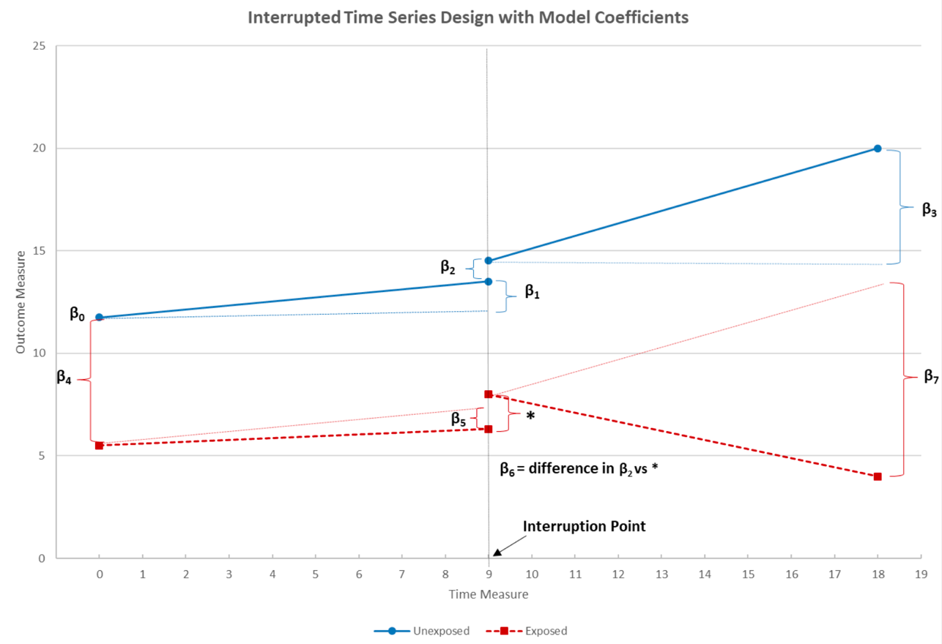

Figure 4.1 Interrupted Time Series Design with Model Coefficients (Image sourced from: Warton, 2020)

While ITS is seldom used in spatial analysis and geographical modelling studies, Zhang and Ning’s study is among the first to introduce a Spatially ITS (SITS) model, whose key concept is that it not only reveals the temporal heterogeneities but can also capture the spatial heterogeneities. SITS is based on the scenario that the effectiveness of a mobility policy is likely to vary between locations due to differences in local attributes, such as the built environment and social factors, rather than spatial relationships like distance or connectivity (Zhang and Ning, 2023). Drawing on this concept, the model in this study will be structured as a multilevel model, estimating temporal causal changes within spatial units in the first-level model and their correlation with the socio-economic characteristics of the corresponding areas in the second-level model.

There are two important and adapted differences in the application of this methodology to Zhang and Ning. Except for using a RITS rather than a single ITS in the first-level model, a new approach is also applied during the second-level model. Inverse Distance Weighting (IDW) is incorporated into the data generation process of the second-level model to address the limitation of SITS when data lacks individual socio-economic attributes. IDW is a widely used spatial interpolation and weighting method, where weights are assigned based on the distance between spatial objects nearby (Gu *et al.*, 2021). In the IDW method, the predicted value of the interpolated points is influenced by the weighted average of the neighbouring observation points, and the weight is determined by the reciprocal of the distance. Specifically, the weight formula is:

$$Weight= \frac{1}{{Distance}^{α}}$$

The parameter $α$ indicates the weight decays with distance by the inverse of the $α$ power of distance, usually used in a range from 1 to 2 in the social science area (English *et al.*, 2003; Yang *et al.*, 2022). It can be adjusted depending on the research question and it is found that IDW with smaller power values performs better (Lu and Wong, 2008). Thus, a value of 1.5 is used here to reflect the idea that high streets are more likely to be influenced by the characteristics of residents living in nearby LSOAs. As ULEZ promotes active travel, ideally, more nearby residents would be encouraged to visit more accessible high streets due to the mobility restrictions.

Overall, the SRITS design developed in this paper has several advantages for this study. Firstly, it not only retains the advantages of basic SITS, allowing it to estimate temporal heterogeneities in both sudden and gradual shifts by capturing the pre- and post-change of level and slope of the exposed group (Lopez Bernal, Cummins and Gasparrini, 2018; Zhang and Ning, 2023) but also strengthens the internal validity by adding a control group to establish a credible underlying trend as a counterfactual scenario. By comparing the behaviour of individuals before and after the intervention (treatment group) with the underlying trend established from the control group, Robust ITS, excluding the erroneous result from treating the average level of change as the only treatment effect (Zhang and Ning, 2023). Second, it can be modelled within a single high street, avoiding bias or unmeasured confounding factors when comparing different geographic units (Lopez Bernal, Cummins and Gasparrini, 2018). Finally, it can specifically estimate what locational factors accelerate or decrease the causal change by containing a multilevel mixed-effects model (Zhang and Ning, 2023), which is vital in exploring the inequity situation in Outer London after the expansion of ULEZ.

## Analytical Stages and Model

This section provides a detailed explanation of the multiple-level SRITS model used in this study, highlighting the model’s key features and providing a detailed explanation of each variable used in the SRITS model, ensuring that future researchers can follow and replicate this study.​

### Level 1 Model Specification

The level 1 model is a mixed-effects model which uses the observed daily visitor counts occurring in 237 high streets of 112 days as the dependent variable over time. Following the structure of Robust ITS in Linden’s paper in 2015, the equation can be written as:

$${Visitor}_{it}= β_{0i}+ β_{1i}* {Time}_{t}+ β_{2i}*{Intervention}_{t}+ β_{3i}*{Time}_{t}* {Intervention}_{t}+ β_{4i}*{Exposed}_{t}+ β_{5i}*{Exposed}_{t}*{Time}_{t}+ β_{6}*{Exposed}_{t}*{Intervention}_{t}+ β_{7i}*{Exposed}_{t}*{Intervention}_{t}*{Time}_{t}+ \sum_{k=1}^{6}{β_{k+7}}{DayofWeek}_{kt}+ ε_{it}$$

*(1)*

Here ${Visitor}_{it}$ is daily visitor number staying at least 10 minutes on high street $I$ $( i=1,2,…,237)$ per 3 hours on day $t$ $( t=1,2,…,112)$. ${Time}_{t}$ is the serial number for each day over the study period, which is equal to $t$ on day $t$. $β_{0i}$ and $β_{1i}$ represents the level and slope of the visitor counts before the intervention; which is the pre-ULEZ secular trend. ${Intervention}_{t}$ is an indicator variable of the ULEZ, which takes on a value of 1 from 23 August 29th to 23 October 24th ($t=56\sim 112$), and 0 otherwise, indicating that the data point falls outside the intervention period. $β_{2i}$ represents the immediate jump in observed visitor counts at the point of intervention. ${Exposed}_{t}*{Time}_{t}$, ${Exposed}_{t}*{Intervention}_{t}$, and ${Exposed}_{t}*{Intervention}_{t}*{Time}_{t}$ are additional interaction terms used in Robust ITS. $Exposed$ is a binary variable indicating the treatment status, where $Exposed$ = 1 for the ULEZ group and $Exposed$ = 0 for the control group. ${Exposed}_{t}*{Time}_{t}$ functions similarly to ${Time}_{t}$, but specifically indicates the trend in treatment group post-ULEZ. ${Time}_{t}* {Intervention}_{t}$ is an interaction term that tracks the number of days since August 29th, 2022, when the high streets were not yet exposed to the second ULEZ expansion. ${Exposed}_{t}*{Intervention}_{t}*{Time}_{t}$ exists for capturing the slope of visitor changes in high streets post-ULEZ expansion. It starts in the observation period immediately following the establishment of the ULEZ $(t=56)$ and runs sequentially until the last observation when $t=112$. $β_{4i}$ captures the level difference in visitor counts between unexposed year and intervention year, while $β_{5i}$ presents the variation in trajectory of visitor counts between 2022 and 2023 pre-intervention. $β_{6}$ represents the difference of outcome jump at the ULEZ expansion date between comparison group. $β_{3i}$ reflects the change in visitor slope after ULEZ in the control group, while $β_{7i}$ captures the slope change in the treatment group relative to $β_{3i}$.

A series of confounders were also controlled in the Level 1 model. $DayofWeek$ is a dummy variable representing Monday to Sunday referring to Friday as the baseline when $k=1\sim 6$. Thus, $β_{8}$ through $β_{14}$ are the coefficients for weekly seasonality and $ε_{it}$ is the residual.

### Level 2 Model Specification

According to the SITS model developed by Zhang and Ning (2023), spatiotemporal heterogeneity is defined as the spatial contextual effect on the temporal pattern of a policy impact. Both the immediate effect (i.e., change in level) and the gradual effect (i.e., change in slope) of the ULEZ intervention, along with the footfall levels on the high streets prior to the policy, are influenced by the spatial context of the surrounding neighbourhoods. In this study, these contexts vary based on the deprivation levels within the communities and the condition of the high street premises.

In this scenario, the coefficients $β_{0i}$ and $β_{6i}$ from Equation 1 are influenced by the socioeconomic profiles of the high streets. As for $β_{3}+ β_{5}$ represents the trend of the unexposed group and $β_{1}+ β_{3}+ β_{5}+ β_{7}$ presents the exposed group. Therefore, $β_{5}+ β_{7}$ indicates the total slope change between comparison groups. Additionally, a new coefficient, $β_{14}$, is introduced to represent the overall slope change throughout the entire study period, which is also affected by the high street profiles. Due to the significant differences in scale between the variables, the level 2 model uses a log-log regression to avoid the model being dominated by extreme values and make the contribution of small and large values to the model more balanced. The corresponding functional relationships are provided by the level 2 model as outlined below:

$${log⁡(β}_{pi})= ζ_{p0}+ ζ_{p1}* {log⁡(IMD}_{ik}) + \sum_{k=1}^{3}{ζ_{p,k+1}}{*log⁡(Spatial}_{ik})+ γ_{pi}, p=0$$

*(2)*

$${log⁡(β}_{pi})= ζ_{p0}+ ζ_{p1}* {log⁡(IMD}_{i}) + \sum_{k=1}^{3}{ζ_{p,k+1}}{*log⁡(Spatial}_{it})+ γ_{pi}, p=6, 14$$

*(3)*

Where ${IMD}_{ik}$ represents the equity features of high streets by a mixed measure based on 7 aspects of deprivation, and ${Spatial}_{it}$ ( $k=1\sim 6)$ represents the built environment features of high streets, including shop categories which are number of leisure services and convenience service, and area of high streets in hectare unit. $ζ_{p0}$ is the mean value of logged $β_{pi}$ at high street level, which represents the averaged daily visitor counts in high street level pre-ULEZ $(p=0)$ and post-ULEZ averaged policy effect $(p=14)$. $γ_{pi}$ is the high street level error. In a log-log regression model, the coefficient can be interpreted as the effect of the relative change in independent variables on the relative change in dependent ones, which is the elasticity coefficient (Benoit, 2011). By substituting Equations 2 and 3 into Equation 1, the spatiotemporal variations in the causal effects of the ULEZ can be estimated.

## Data Preparation

Data preparation involves cleaning, organizing, and structuring original data to make it suitable for the setup of ITS. Most importantly, it explains the workflow used to match control groups and build demographic and financial profiles for each high street.

### Workflow

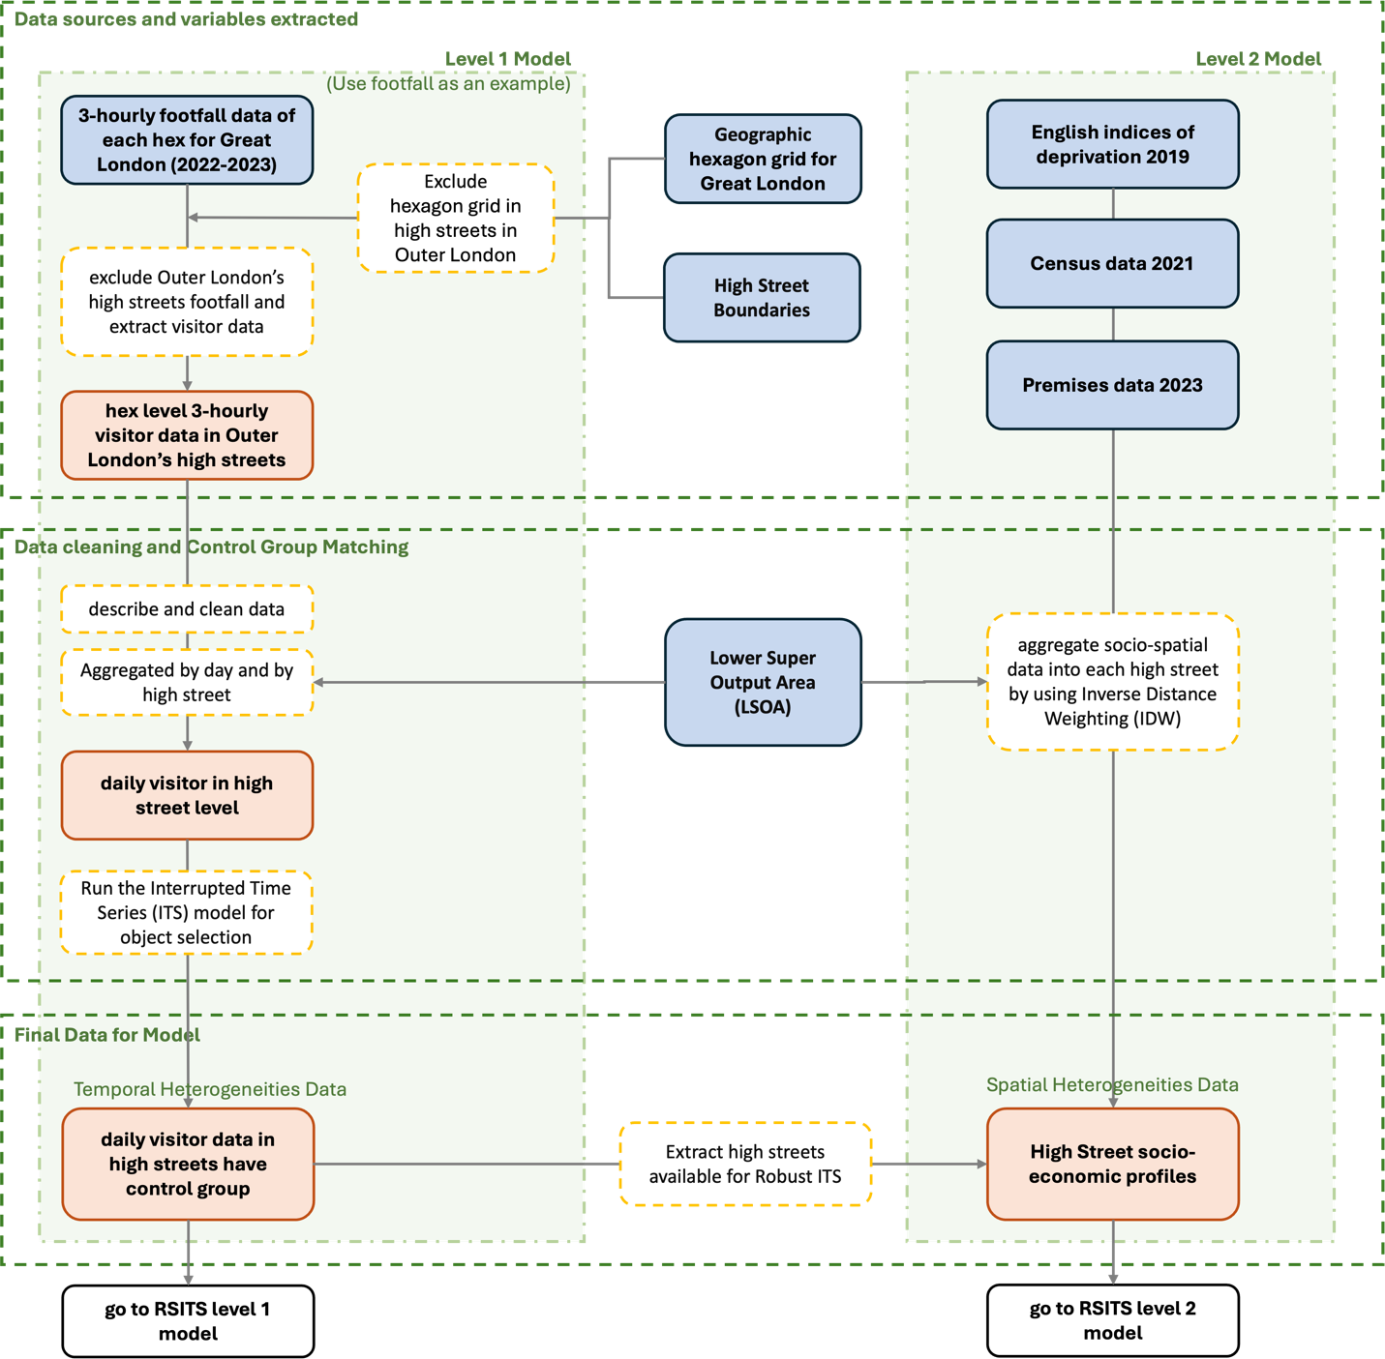

Figure 4.2 Framework of Data Processing Stage

As illustrated in Figure 4.2, this outline of the data processing includes two data processing flows corresponding to two levels of the model and three analytical stages. Firstly, in the data sources and variable extraction stage, the footfall data for 2022 and 2023 is derived from the original 3-hourly data at the hex level. In the data cleaning and control group matching stage, the key processing step involves matching comparable control groups with the treatment groups, which will be thoroughly discussed and validated in the later section. The final dataset for modelling is obtained in the third stage. The first flow produces temporal data that captures the causal effects and temporal heterogeneities associated with the ULEZ intervention, while the second flow generates the socio-spatial profiles reflecting the deprivation in surrounded LSOAs and built environment features of high streets. After these processes, the data is ready for RSITS analysis.

### Data Cleaning

Through exploring the raw footfall data, it was discovered that there are some NA rows in the visitor footfall. Upon investigation, these grids with NA value correspond to areas with no population, such as hexagons over the Thames River, areas unoccupied at night, or regions with low populations (lower than 10) where suppression of low numbers is necessary to ensure anonymization. In this case, I replaced the NA rows with 0, which may carry the risk of underestimating the results. Apart from this, the issue of random negative values in the raw visitor data is addressed by replacing these negative values with a more representative figure, specifically, the mean visitor counts for the same weekday in the surrounding weeks.

### Matching Control Groups

The most important step before modelling with a Robust Interrupted Time Series is to match suitable control groups for treatment groups. This typically requires that seasonality and other cyclical trends are parallel between the groups, ensuring that the unexposed group serves as an appropriate comparison group. Thus, the former year’s data is chosen as a control group in this paper, under the consideration of controlling locational variations to avoid bias or unmeasured confounding factors when comparing different geographic units as mentioned in section 4.1.

To assess covariate balance, the holidays and weekdays between the 2022 control group and the 2023 control group must be perfectly aligned. In 2022, the Summer Bank Holiday fell on Monday, August 28th, while in 2023, it occurred on Monday, August 29th. Since holidays and weekly trends are significant confounders that indirectly affect the number of visitors on nearby high streets, it is essential to ensure that they are properly aligned between comparison groups. To avoid any potential biases, all dates in the 2022 control group were shifted backwards by one day to align with the national public holiday schedule and week.

When analysing time series data, a visual inspection of the series over time is the first essential step since having the ability to present the intuitive graphical presentation of results is one of the key advantages of interrupted time series studies (Wagner *et al.*, 2002). Thus, segmented regression plots of each high street’s daily visitor number were plotted to roughly check its parallel trend pre-intervention.

Figure 4.3 Segmented Regression Plot of Manor Road High Street

Figure 4.4 Segmented Regression Plot of Bridge Road High Street

In addition to this, it is necessary to run an interrupted time series (ITS) analysis to evaluate the statistical significance of the difference. To test the comparability between groups on observed covariates and in particular, $β_{4}$ and $β_{5}$ from the basic ITS equation mentioned in section 4.1 are the most important two parameters, playing a particularly crucial role in assessing whether the comparison groups are comparable in terms of the level and slope of outcome variables before the intervention. Lower p-values of $β_{4}$ and $β_{5}$ indicate smaller pre-intervention differences in a statistical sense, inversely higher similarity. While this equivalence cannot be guaranteed in observational studies, similar trends and trajectories are expected prior to the intervention (Linden and Adams, 2011).

Since I aim to control for seasonality confounders, $β_{5}$ warrants greater attention. Therefore, groups with a p-value greater than the specified threshold for the $β_{5}$ coefficient of the *exposed*time* interaction term were retained as controls for the final model. Comparability in the current research is defined as having a p-value greater than 0.05 on $β_{5}$. Ultimately, out of 419 high streets, 237 were identified as having statistically significant control groups with trends parallel to the 2023 daily visitor data, as illustrated by Manor Road in Wallington (Figure 4.3). In contrast, the remaining high streets, such as Bridge Road in Chessington (Figure 4.4), did not exhibit comparable trends. Therefore, the RSITS will be analysed on these 237 high streets.

### Building Socio-spatial Profiles for High Streets

Based on previous studies investigating the factors influencing the vitality of high streets, various factors such as population profiles, proportion of town centres and components of established facilities (Enoch *et al.*, 2022; Carmona, 2015) have been found correlated. As Carmona (2015) notes, there are one-third of users on high streets coming from more than 1 km away, and Londoners travel a lot to do their shopping, on average 1.9 miles for food shopping and 3.5 miles for nonfood (GLA Economics, 2006). Refer to this, the Inverse Distance Weighting (IDW) is run within a 2-km distance to catch the socio-economic make-up of potential consumers to dictate the high street profile. Profiles are considered from two dimensions. The first one is the equity heterogeneity of high streets, which reflects on the variations in nearby neighbourhoods’ multiple deprivation ranks, which are measured by the Index of Multiple Deprivation, measured by 7 domains in deprivation rank including income, living environment, health, etc. The second one is the spatial heterogeneity of high streets, which reflects on the variations in built retail facilities features, such as convenience, retail service, leisure service, etc.

# Results

This chapter presents the results derived from the methodology outlined in the previous chapter. The interpretation of the model results will be approached from three perspectives: the temporal causal effect of ULEZ, the socio-spatial heterogeneities in the baseline levels of high street visitors, and the abrupt and gradual changes following the policy implementation.

## Temporal Heterogeneity in Policy Effects

Table 5.1 below presents the results of the two-level model, categorized and summarized according to the relevant themes of the model. The “Temporal heterogeneity in policy effects” and above refer to the first-level result, while the “Socio-spatial heterogeneity in high streets” shows the result from equation 3, “Spatiotemporal heterogeneity in gradual policy effects” and “Spatiotemporal heterogeneity in abrupt policy effects” include the second-level result from equation 3. The variance at Level 1 significantly contributes to the total variance, suggesting that mixed-effects models outperform fixed-effects ones.

Table 5.1 Full Estimates of the Spatially Robust Interrupted Time-series Model

|  |  |  |  |
| --- | --- | --- | --- |
|  | **Variable names, coefficient parameters** | **Coefficient** | **P-value** |
| Initial level of pre-ULEZ visitor in unexposed group | *Intercept, $β_{0}$* | *175.397* | *0.000* |
| Slope of pre-ULEZ visitor in unexposed group | *Time, $β_{1}$* | *-0.286* | *0.000* |
| Sudden change of visitor in unexposed group when ULEZ interrupt | *Intervention, $β_{2}$* | *9.464* | *0.000* |
| Slope of post-ULEZ visitor in unexposed group | *Intervention*Time, $β_{3}$* | *-0.580* | *0.000* |
| Difference in level in exposed group compared to unexposed group pre-ULEZ | *Exposed, $β_{4}$* | *-9.034* | *0.000* |
| Difference in slope in exposed group compared to unexposed group pre-ULEZ | *Exposed*Time, $β_{5}$* | *-0.193* | *0.000* |
| Effect of time-varying confounders on the visitor count (treat Friday as baseline) | *Mon, $β_{8}$* | *10.624* | *0.000* |
| *Tue, $β_{9}$* | *-7.797* | *0.000* |
| *Wed, $β_{10}$* | *-10.833* | *0.000* |
| *Thu, $β_{11}$* | *-13.284* | *0.000* |
| *Sat, $β_{12}$* | *10.798* | *0.000* |
| *Sun, $β_{13}$* | *6.998* | *0.000* |
| **Temporal heterogeneity in policy effects** |  |  |  |
| Difference of sudden change on visitor counts due to ULEZ | *Exposed*Intervention, $β_{6}$* | *-32.679* | *0.000* |
| Difference in slope between comparison groups on visitor counts due to ULEZ | *Exposed*Intervention *Time, $β_{7}$* | *1.758* | *0.000* |
| Net difference in slope between comparison groups on visitor counts in whole study period | $${β_{14} (β}_{5}+ β_{7})$$ | *1.565* |  |
| **Socio-spatial heterogeneity in high streets** |  |  |  |
| Effects of socioeconomic and built facilities features on pre- visitor counts level (p=0) | *IMD decile, $ζ_{01}$* | *-0.496* | *0.000* |
| *Leisure service, $ζ_{02}$* | *0.033* | *0.010* |
| *Convenience, $ζ_{03}$* | *-0.001* | *0.940* |
| *Area (ha), $ζ_{04}$* | *0.214* | *0.000* |
| **Spatiotemporal heterogeneity in gradual policy effects** |  |  |  |
| Effects of socioeconomic and built facilities features on gradual visitor counts change (p=14) | *IMD decile, $ζ_{141}$* | *-0.444* | *0.000* |
| *Leisure service, $ζ_{142}$* | *0.034* | *0.001* |
| *Convenience, $ζ_{143}$* | *0.001* | *0.825* |
| *Area (ha), $ζ_{144}$* | *0.088* | *0.003* |
| **Spatiotemporal heterogeneity in abrupt policy effects** |  |  |  |
| Effects of socioeconomic and built facilities features on abrupt visitor counts change (p=6) | *IMD decile, $ζ_{61}$* | *0.493* | *0.000* |
| *Leisure service, $ζ_{62}$* | *-0.012* | *0.435* |
| *Convenience, $ζ_{63}$* | *-0.002* | *0.799* |
| *Area (ha), $ζ_{64}$* | *-0.116* | *0.011* |
| Group Variation for Level1 | *9063.17* |  |  |
| R-squared for level2 (p=0) | *0.45* |  |  |
| R-squared for level2 (p=14) | *0.35* |  |  |
| R-squared for level2 (p=6) | *0.16* |  |  |
| No. Groups | *237* |  |  |

This section focuses on the estimation of temporal heterogeneity in the treatment effects of ULEZ intervention policy. According to the full estimation of RSITS (Table 5.1), before the ULEZ in 2023, the average visitor volume at ${Time}_{t} ( t=0)$ in high streets in Outer London is significantly 166 people ${(β}_{0}+ β_{4})$ per day. Following this, the number of visitors gradually declined at a rate of 1 person every two days pre-ULEZ. Notably, the post-ULEZ trend shows that the treatment group experienced an increase of 1.8 visitors per day, while the control year’s coefficient suggests that the counterfactual visitor counts would be decreasing by 0.58 per day over the same period. Hence, the second expansion of the ULEZ across London led to a net daily increase of 1.6 visitors ${(β}_{14})$ on average across all high streets, with both difference estimations pre- ${(β}_{5})$ and post- ${(β}_{7})$ ULEZ are highly significant. Additionally, the results indicate that the abrupt response of visitors on high streets to the ULEZ on the policy implementation date was a sharp decline of nearly 32.8 visitors ${(β}_{6})$.

Additionally, based on the results capturing weekly trends using confounder $DayofWeek$, I found that high streets of Outer London are particularly active on weekends, with 10.8 additional visitors on Saturdays ${(β}_{12})$ and 7 more on Sundays ${(β}_{13})$ compared to the baseline volume on Fridays. Interestingly, Mondays also see unexpectedly high activity on high streets, with a visitor count comparable to Saturdays, reaching 10.6 ${(β}_{8})$. This is consistent with the trend revealed in Figure 4.3.

## Socio-spatial Heterogeneity in Baseline Footfall (P = 0)

This section examines whether and how the social and spatial environments, especially the deprivation indicator of the LSOAs surrounding the high streets influence the visitor volume on high street activity before ULEZ, as shown in Table 5.1.

It can be observed that before the second ULEZ expansion, within a 2km radius, if the IMD decile of the LSOAs served by high streets increases by 1% (with higher deciles indicating less deprivation), the average visitor volume on those high streets tends to decrease by 0.50% ${(ζ}_{01})$, further proving that poorer families in Outer London are more likely to frequent nearby high streets. This may be due to the high rates of non-car ownership among deprived households (Lucas *et al.*, 2019), limiting their ability to travel longer distances. Additionally, a 1% increase in the number of shops in this category is associated with more than a 0.03% ${(ζ}_{02})$ rise in visitor numbers. However, there appears to be no correlation between the convenience store category and high street footfall. Finally, when the scale of high streets goes up by 1%, the visitor number attracted by high streets rises by 0.21% ${(ζ}_{04})$. This can be seen in Figure 5.1, which is plotted by the actual $β_{0}$ in each high street as above, demonstrating the spatial variations of the baseline visitor counts.

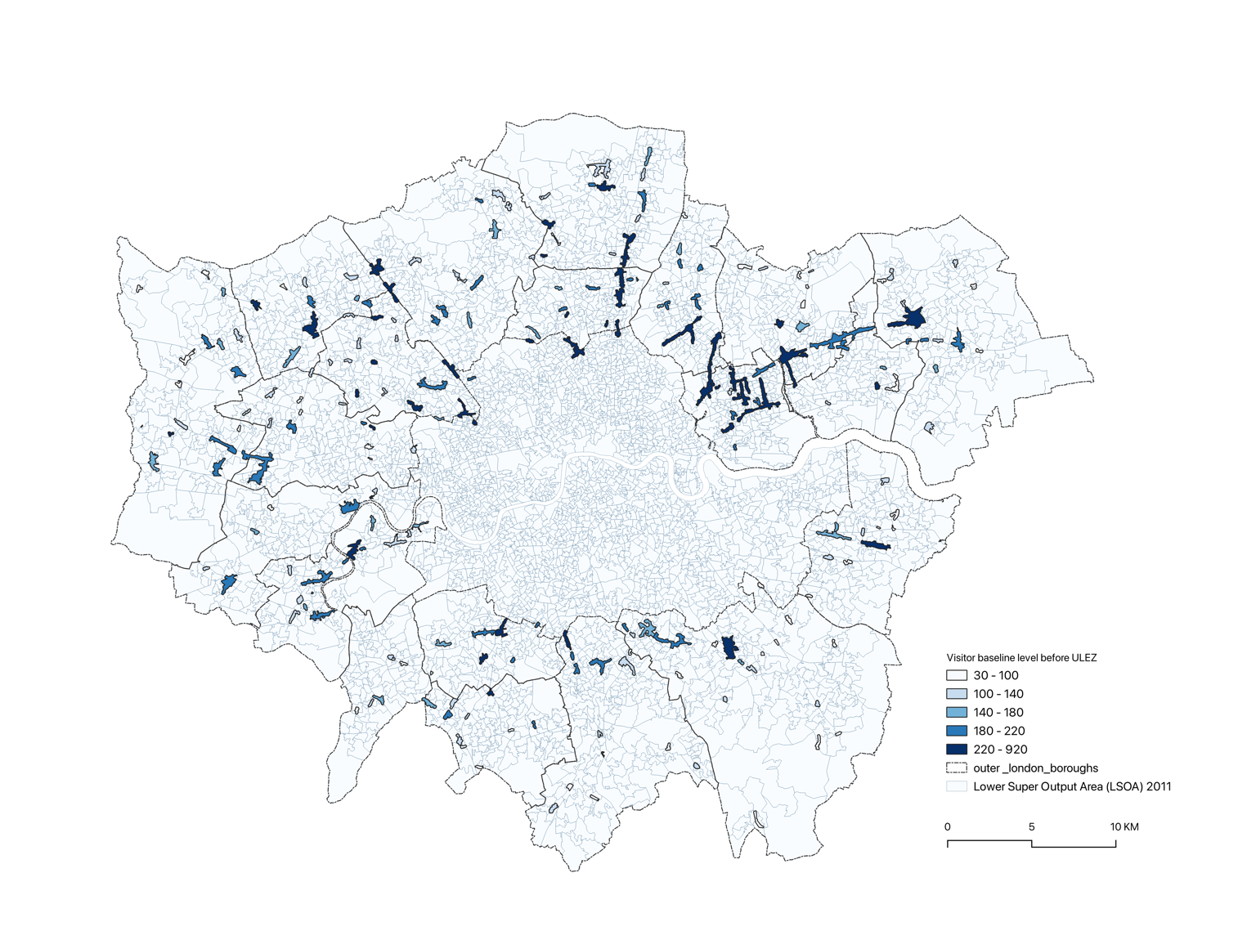

Figure 5.1 Map of Visitor Baseline Level in Each High Street Pre-ULEZ

## Socio-spatial Heterogeneities in Gradual Policy Effects (P = 14)

This section examines the social and spatial heterogeneities in policy effects by exploring how the gradual impacts of policy interventions differ across various high-street-level spatial contexts.

According to Table 5.1, the gradual net difference in treatment groups shows a significantly strong positive correlation with the IMD decile, where a 1% increase in IMD decile corresponds to a 0.44% ${(ζ}_{141})$ decrease in visitor growth. This strongly suggests that after the ULEZ implementation, residents in deprived communities began frequenting high streets more than those in affluent areas. Figure 5.2 below illustrates the spatial distribution of the IMD decile for each LSOA, alongside the change in visitor slope due to ULEZ. There is a noticeable correlation on the map between more deprived areas (lighter blue) and a higher increase (darker red) in visitor counts, , suggesting that the ULEZ restrictions have a greater impact on limiting travel for people in poorer areas, preventing them from visiting their usual shopping destinations as compared to those in wealthier regions. This trend could be attributed to a lower compliance rate with ULEZ standards among car owners in poorer areas, since generally, higher-emission vehicles are cheaper to purchase compared to lower ones (ICCT, 2024).

Additionally, it is evident that the mix level of businesses on a high street also enhances its vitality after ULEZ. High streets with a greater number of leisure services, such as restaurants, cafes, fast food outlets, and takeaways, are notably more attractive than convenience services to residents of surrounding LSOAs. When the number of stores offering leisure services on high streets increases by 1%, it results in a 0.03% ${(ζ}_{142})$ rise in the overall visitor count, while the result is nearly zero for convenience. This finding underscored that Londoners started to travel for food shopping in a short distance, which might be due to the car usage for long-distance leisure activities being replaced by walking, cycling, or public transport under the ULEZ impact.

At the same time, high streets with greater area size encourage more visitor activity in the long run, as a 1% increase in high street size notably results in a 0.08% ${(ζ}_{144})$ boost in foot traffic. This might likely be due to their greater scale allowing for a more diverse composition of establishments. This diversity enables them to better meet the varied needs of the local population, including those of different ethnic groups (Carmona, 2015), allowing them to have greater potential to accommodate a wider range of activities. Serving as exchange spaces is a key factor widely recognised as essential for a high street's success.

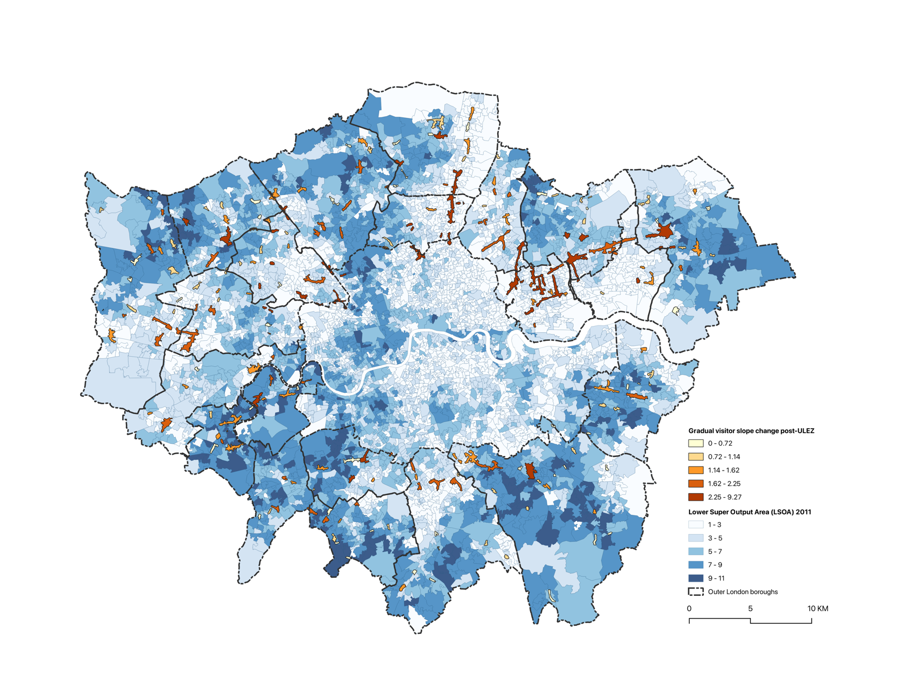

Figure 5.2 Map of Gradual Visitor Change in Each High Street Post-ULEZ

Looking at the map above, a densely packed cluster of high streets in Northeast Outer London with significantly higher visitor growth can be observed, where Westfield Stratford is located. Similarly, in North London, several interconnected high streets stretch from Haringey to Enfield, also showing substantial visitor increases. This demonstrates a clear siphoning effect: high streets with large shopping centres and strong connectivity to surrounding shopping areas tend to attract more visitors.

## Socio-spatial Heterogeneities in Gradual Policy Effects (P = 6)

This section examines the abrupt impacts of policy interventions with their various underlying high-street-level spatial contexts. According to the results in Table 5.1, on the day of ULEZ implementation, areas with a 1% increase in IMD decile saw a statistically significant 0.49% rise in the number of people staying on high streets for at least 10 minutes. This aligns with Figure 5.3, wealthier high streets (surrounded by darker blue LSOAs) show a negative increase (lighter yellow) in visitor numbers while visitors in poorer high streets show a slightly positive increase. Interestingly, this change is unrelated to the retail category of the high streets, but rather to their size. Specifically, for every 1% decrease in high street area, footfall increased by 0.12%. This appears to be in contrast with the gradual impact.​ It suggests that smaller commercial centres experienced more pronounced effects on the day of ULEZ implementation, indicating that ULEZ has influenced the behaviour of some small-centred town residents, prompting them to visit nearby high streets rather than travel further afield. However, this result only represents a snapshot of the changes and cannot fully capture the ongoing shifts in visitor patterns, as it is based on the impact of a single day and falls on a weekday.

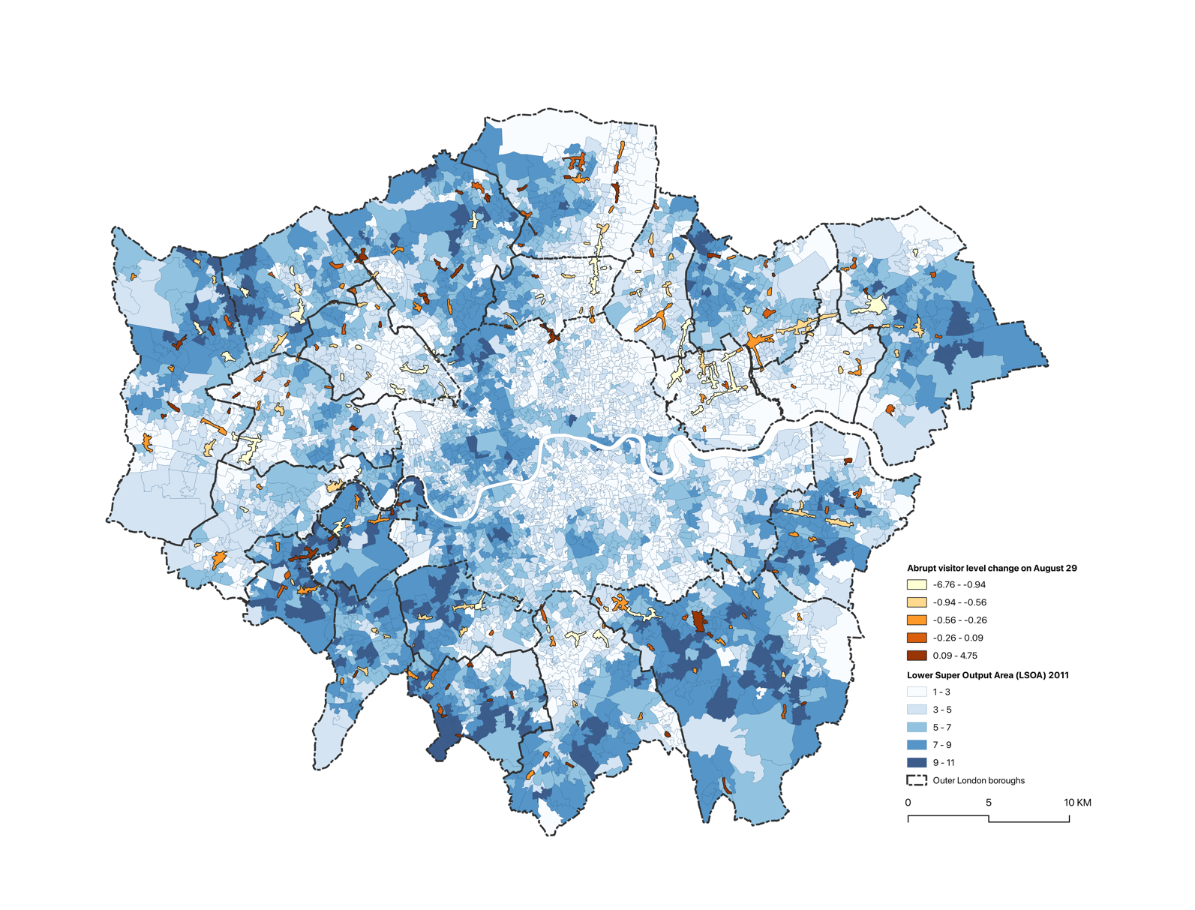

Figure 5.3 Map of Abrupt Visitor Change in Each High Street on ULEZ Expansion Date

Comparing spatiotemporal heterogeneities in terms of abrupt and gradual policy effects shows that high streets around deprived LSOAs with a larger scale and higher percentage of leisure premises were less sensitive to the ULEZ at the beginning but attracted more visitors after the interruption of the policy in a long run.

# Discussion

This chapter explains and expands on the results of the analysis presented in the last chapter and tries to give answers to the research questions outlined at the start.

## How does ULEZ affect the Vitality of High Streets?

In the last chapter, the temporal heterogeneities of the policy effects were identified by analysing the average abrupt and gradual impacts caused by ULEZ. The results indicated that ULEZ led to an immediate drop in visitor counts on Outer London’s high streets by 32.68 people, representing 19.6% of the baseline level prior to the policy's implementation. However, over time, the number of visitors gradually increased at a rate of 1.6 people per day. This suggests that the impact of the policy intervention was not constant. While ULEZ initially suppressed footfall on high streets on the day of its implementation, over time, as daily routines and leisure activities resumed, the policy began to help local high streets attract more footfall. The overall findings suggest that the expansion of the ULEZ across London has significantly encouraged Outer London residents to frequent their local high streets. This validates the hypothesis outlined in section 2.4, suggesting that car traffic restrictions may have effectively promoted active travel, or improved the safety and air quality of high streets due to reduced traffic. In turn, these factors have revitalized local businesses and enhanced the vibrancy of town centres.

## How does ULEZ affect inequality in Outer London?

From the results in section 5.1.2, it is evident that poorer neighbourhoods tend to visit nearby high streets more frequently before the ULEZ expansion, indicating that social inequality was already present due to both spatial and transport disadvantages. Transport disadvantages may stem from the fact that, for low-income households, driving is often a luxury, as these families are more likely to be without car ownership (Lucas *et al.*, 2019). Additionally, affordable and sustainable transport options are not as widely promoted in Outer London as they are in Inner London (Mahmud, Cottell and Harding, 2023). As a result, deprived communities have limited capacity for long-distance travel. Spatial disadvantages, on the other hand, likely arise from the poor quality of local high streets, evidenced by the reluctance of wealthier residents to drive to these areas. All these have resulted in an inverse relationship between the IMD index and high street activity even before ULEZ implementation, as discussed in section 5.3. Due to their limited means, poorer households are unable to travel long distances to access larger high streets, opting instead to frequent closer, smaller facilities.

This existing social inequality has been further intensified by the implementation of ULEZ. While most high streets have seen an overall increase in footfall, the growth in visitor numbers has been significantly larger on high streets located in more deprived areas compared to those in affluent LSOAs. This disparity may stem from the fact that, although certain vehicles are banned in these neighbourhoods, the impact is more pronounced for deprived households, as higher-emission vehicles tend to be more affordable in the market (ICCT, 2024), aligning with the lower purchasing power of these families. The ULEZ mobility policy disproportionately restricts the ability of poorer households to drive for shopping, increasing their financial burden and exacerbating existing inequalities. Additionally, Outer London is a car-dependent area where sustainable transport options are not as widely encouraged as they are in Inner London (Mahmud, Cottell and Harding, 2023). This lack of alternative transportation further deepens the strain on deprived families, who find it difficult to replace their driving routines. According to a report by Social Exclusion Unit (2003), issues with transportation availability and the location of services can exacerbate social exclusion by hindering access to essential local resources and activities, such as employment, education, healthcare, grocery shopping, and leisure.​ Overall, while ULEZ has boosted footfall on high streets, it has also exposed and heightened the differences in its impact, deepening the existing inequalities in these disadvantaged areas, which may ultimately lead to social exclusion.

## Demand for Outer London

According to the London Plan, to create high-quality and sustainable Outer London neighbourhoods, providing ‘sufficient, good quality social infrastructure provision’ is one of the keys (Mayor of London, 2016). It is important to understand the diversity of characteristics behind high streets so that can play to local strengths and encourage the vibrancy of town centres and high streets. From a strategic perspective outlined by Carmona (2015), high streets play a vital role in supporting civic life and benefiting all Londoners, as they are an integral part of people's daily lives and inescapable elements of the urban landscape. The positive correlation between IMD and the increase in visitors suggests that the lives of the vulnerable groups in Outer London are facing some problems. In addition to economically disadvantaged populations, more deprived neighbourhoods also tend to have a higher concentration of unhealthy, vulnerable, and less mobile groups, such as the elderly and people with disabilities. Therefore, in terms of developing policies aimed at enhancing high street vitality, planners need to consider building facilities that cater to the needs of these populations, where improving public transport accessibility further and capitalising on the significant concentration of mixed-use developments existing are sustainable and humanized solutions to stimulate existing development potential, as Carmona (2015) suggested.

In addition to deprived residents, poorly built environments are also worth noting. IMD indicates a neighbourhood has a higher percentage of victimization, worse road traffic and outdoor air quality, causing safety issues that people are concerned about (Carmona, 2015). The estimation results presented in the results chapter indicate that poorer LSOAs’ residents are limited to shopping on nearby high streets, which is equal to forcing residents to frequent these less well-maintained or lower-quality areas. It is reported that approximately two-thirds of Londoners reside within 400 meters, or a 5-minute walk, from a high street (Carmona, 2015). This indicates a significant percentage of the population’s target high streets will be shifted into worse high streets. However, it is unjust to restrict people’s right to travel to safer, more vibrant high streets for shopping and leisure without providing them with equally high-quality alternatives in their vicinity. What’s more, social exclusion happens when developments like retail centres are situated in areas that are difficult to reach without a car, limiting access for those without private transportation (Social Exclusion Unit, 2003).​ Therefore, the government is suggested to focus on improving Outer London’s high streets by enhancing safety, promoting sustainability, and fostering livability. These improvements would better accommodate the evolving lifestyle of residents while also playing a significant role in addressing and reducing social inequalities in the area. It is crucial to acknowledge the needs and potential of the large residential populations already living on and around Outer London’s high streets.​ Developing and updating high street retail and quality of service for these users and significantly benefits their quality of life is the direct way for success on the rejuvenation of the local economy and enhancement of town centres vibrancy.

## limitations

Several limitations should be highlighted in this study. First, although the methodology in this research introduced some innovations, further research is still needed to refine the approach to spatiotemporal causal inference. Future research could integrate finer-grained spatial data and account for population density when calculating socio-spatial weights, allowing for a more accurate representation of real-world conditions. Besides, this study faces limitations specifically due to the narrative range of variables the model considered. A typical high street is a complex and dynamic socio-spatial entity (Griffiths *et al.*, 2008). Given the complexity of high street footfall, people visit for a variety of purposes, such as shopping, work, leisure, passing through, and even prayer (Carmona, 2015), all of which are tied to the composition of high street facilities. Future research could benefit from combining more relevant variables into the model to provide more robust control and more comprehensive exploration.

# Conclusion

To address the challenges for the revitalization of high streets and enhancing the vibrancy of town centres in Outer London, as well as to explore the potential causal impact of the Ultra Low Emission Zone (ULEZ) expansion to London-wide on August 29, 2023, on the local economy, this research set out to investigate and answer three key questions.

First, it quantified the causal impact of the second expansion of the ULEZ policy on visitor patterns in Outer London. Second, it explored the policy's effects on social equity. Lastly, it examined the socio-spatial heterogeneity in these causal impacts. The entire study employed the Robust Spatial Interrupted Time Series (RSITS) method, an adaptation of Zhang and Ning's SITS design, which strengthened the model's ability to control for seasonal trends by incorporating comparative groups, ensuring internal validity. Additionally, the unique multi-level structure of the model enabled an analysis of how social and spatial features of the LSOAs surrounding different high streets influenced their response to ULEZ.

The findings indicate that the ULEZ expansion in Outer London did indeed encourage more residents to visit nearby high streets. However, this effect was not evenly distributed; it disproportionately impacted deprived neighbourhoods, exacerbating the tendency for residents of these areas to frequent their closest high streets. The study also revealed that the retail composition and size of a high street significantly influence its vitality.

In conclusion, the results reveal the relationship between mobility policy and high street vitality and highlight the importance of supporting local businesses in Outer London, particularly in deprived areas. These insights offer valuable guidance for developing strategies and priorities for the future of Outer London's high streets in the post-ULEZ era.

# Acknowledge

First, I would like to express my deepest gratitude to my supervisor, Dr. Chen Zhong and Yikang Wang. Your patient and meticulous guidance during every meeting, and your always timely responses to my many emails filled with questions, were invaluable in helping me complete this dissertation. Without your support, I would not have enjoyed this research journey as much as I did, and for that, I am incredibly thankful. I am also sincerely grateful to you both for choosing me and offering me this project — love you both! Additionally, I would like to extend my thanks to Zhengzi Zhou, a PhD student at CASA, for his assistance. Furthermore, I am grateful to the Greater London Authority (GLA) for providing me with the necessary license and data to carry out the methodology for this work. This project has brought my master's journey to a fulfilling conclusion. Lastly, I acknowledge the use of ChatGPT 4o (Open AI, https://chat.openai.com) to proofread my final draft.

# Bibliography

Abegaz, T., Berhane, Y., Worku, A. and Assrat, A. (2014). ‘Effectiveness of an improved road safety policy in Ethiopia: an interrupted time series study’. *BMC Public Health*, 14 (1), p. 539. doi: 10.1186/1471-2458-14-539.

Barton, H., Horswell, M. and Millar, P. (2012). ‘Neighbourhood Accessibility and Active Travel’. *Planning Practice and Research*, 27 (2), pp. 177–201. doi: 10.1080/02697459.2012.661636.

Benoit, K. (2011). ‘Linear Regression Models with Logarithmic Transformations’.

Burrough, P. A. and McDonnell, R. A. (1993). ‘Principles of Geographical Information Systems’.

Carmona, M. (2015). ‘London’s local high streets: The problems, potential and complexities of mixed street corridors’. *Progress in Planning*, 100, pp. 1–84. doi: 10.1016/j.progress.2014.03.001.

Charleux, L. (2014). ‘Contingencies of environmental justice: the case of individual mobility and Grenoble’s Low-Emission Zone’. *Urban Geography*, 35 (2), pp. 197–218. doi: 10.1080/02723638.2013.867670.

Department for Business, Innovation and Skills. (2011). ‘Understanding High Street performance’.

Department of Travel. (2023). ‘National Travel Survey England 2022’.

Ding, H., Sze, N. N., Guo, Y. and Lu, Y. (2023). ‘Effect of the ultra-low emission zone on the usage of public bike sharing in London’. *Transportation Letters*. Taylor & Francis, 15 (7), pp. 698–706. doi: 10.1080/19427867.2022.2082005.

Dorais, S. (2024). ‘Time series analysis in preventive intervention research: A step‐by‐step guide’. *Journal of Counseling & Development*, 102 (2), pp. 239–250. doi: 10.1002/jcad.12508.

Ellison, R. B., Greaves, S. P. and Hensher, D. A. (2013). ‘Five years of London’s low emission zone: Effects on vehicle fleet composition and air quality’. *Transportation Research Part D: Transport and Environment*, 23, pp. 25–33. doi: 10.1016/j.trd.2013.03.010.

English, P. B., Kharrazi, M., Davies, S., Scalf, R., Waller, L. and Neutra, R. (2003). ‘Changes in the spatial pattern of low birth weight in a southern California county: the role of individual and neighborhood level factors’. *Social Science & Medicine*, 56 (10), pp. 2073–2088. doi: 10.1016/S0277-9536(02)00202-2.

Enoch, M., Monsuur, F., Palaiologou, G., Quddus, M. A., Ellis-Chadwick, F., Morton, C. and Rayner, R. (2022). ‘When COVID-19 came to town: Measuring the impact of the coronavirus pandemic on footfall on six high streets in England’. *Environment and Planning B: Urban Analytics and City Science*, 49 (3), pp. 1091–1111. doi: 10.1177/23998083211048497.

Farrington, J. H. (2007). ‘The new narrative of accessibility: its potential contribution to discourses in (transport) geography’. *Journal of Transport Geography*, 15 (5), pp. 319–330. doi: 10.1016/j.jtrangeo.2006.11.007.

Gärling, T., Kalén, T., Romanus, J., Selart, M. and Vilhelmson, B. (1998). ‘Computer Simulation of Household Activity Scheduling’. *Environment and Planning A: Economy and Space*, 30 (4), pp. 665–679. doi: 10.1068/a300665.

Gorman, D., Douglas, M. J., Conway, L., Noble, P. and Hanlon, P. (2003). ‘Transport policy and health inequalities: a health impact assessment of Edinburgh’s transport policy’. *Public Health*, 117 (1), pp. 15–24. doi: 10.1016/S0033-3506(02)00002-1.

Gozzi, N., Tizzoni, M., Chinazzi, M., Ferres, L., Vespignani, A. and Perra, N. (2021). ‘Estimating the effect of social inequalities on the mitigation of COVID-19 across communities in Santiago de Chile’. *Nature Communications*, 12 (1), p. 2429. doi: 10.1038/s41467-021-22601-6.

GREATER LONDON AUTHORITY. (2017). ‘Clearing The Air’.

Greater London Authority. (2020). ‘AIR QUALITY IN LONDON 2016-2020.pdf’.

Griffiths, S., Vaughan, L., Haklay, M. (Muki) and Emma Jones, C. (2008). ‘The Sustainable Suburban High Street: A Review of Themes and Approaches’. *Geography Compass*, 2 (4), pp. 1155–1188. doi: 10.1111/j.1749-8198.2008.00117.x.

Gu, K., Zhou, Y., Sun, H., Dong, F. and Zhao, L. (2021). ‘Spatial distribution and determinants of PM2.5 in China’s cities: fresh evidence from IDW and GWR’. *Environmental Monitoring and Assessment*, 193 (1), p. 15. doi: 10.1007/s10661-020-08749-6.

ICCT. (2024). ‘EUROPEAN VEHICLE MARKET STATISTICS’.

Jansen, M. F. (2021). ‘Analysing and comparing sustainability strategies from an economically profitability perspective.pdf’.

Jones, P. and Lucas, K. (2012). ‘The social consequences of transport decision-making: clarifying concepts, synthesising knowledge and assessing implications’. *Journal of Transport Geography*, 21, pp. 4–16. doi: 10.1016/j.jtrangeo.2012.01.012.

Lai, S., Sorichetta, A., Steele, J., Ruktanonchai, C. W., Cunningham, A. D., Rogers, G., Koper, P., Woods, D., Bondarenko, M., Ruktanonchai, N. W., Shi, W. and Tatem, A. J. (2022). ‘Global holiday datasets for understanding seasonal human mobility and population dynamics’. *Scientific Data*, 9 (1), p. 17. doi: 10.1038/s41597-022-01120-z.

Linden, A. (2015). ‘Conducting Interrupted Time-series Analysis for Single- and Multiple-group Comparisons’. *The Stata Journal: Promoting communications on statistics and Stata*, 15 (2), pp. 480–500. doi: 10.1177/1536867X1501500208.

Linden, A. and Adams, J. L. (2011). ‘Applying a propensity score-based weighting model to interrupted time series data: improving causal inference in programme evaluation: Weighted interrupted times series analysis’. *Journal of Evaluation in Clinical Practice*, 17 (6), pp. 1231–1238. doi: 10.1111/j.1365-2753.2010.01504.x.

Lopez Bernal, J., Cummins, S. and Gasparrini, A. (2016). ‘Interrupted time series regression for the evaluation of public health interventions: a tutorial’. *International Journal of Epidemiology*, p. dyw098. doi: 10.1093/ije/dyw098.

Lopez Bernal, J., Cummins, S. and Gasparrini, A. (2018). ‘The use of controls in interrupted time series studies of public health interventions’. *International Journal of Epidemiology*, 47 (6), pp. 2082–2093. doi: 10.1093/ije/dyy135.

Lu, G. Y. and Wong, D. W. (2008). ‘An adaptive inverse-distance weighting spatial interpolation technique’. *Computers & Geosciences*, 34 (9), pp. 1044–1055. doi: 10.1016/j.cageo.2007.07.010.

Lucas, K. (2006). ‘Providing transport for social inclusion within a framework for environmental justice in the UK’. *Transportation Research Part A: Policy and Practice*, 40 (10), pp. 801–809. doi: 10.1016/j.tra.2005.12.005.

Lucas, K. (2012). ‘Transport and social exclusion: Where are we now?’ *Transport Policy*, 20, pp. 105–113. doi: 10.1016/j.tranpol.2012.01.013.

Lucas, K., Stokes, G., Bastiaanssen, J. and Burkinshaw, J. (2019). ‘Inequalities in Mobility and Access in the UK Transport System’.

Mahmud, Z., Cottell, J. and Harding, C. (2023). ‘Moving with the Times: Supporting sustainable travel in outer London’.

Mayor of London. (2016). ‘The London Plan’.

Mayor of London. (2023). ‘London-wide ULEZ first month report.pdf’.

Mumford, C., Parker, C., Ntounis, N. and Dargan, E. (2021). ‘Footfall signatures and volumes: Towards a classification of UK centres’. *Environment and Planning B: Urban Analytics and City Science*, 48 (6), pp. 1495–1510. doi: 10.1177/2399808320911412.

Parker, C., Ntounis, N., Quin, S. and Millington, S. (2016). *High Street UK 2020 Project Report*. Institute of Place Management. doi: 10.23634/MMU.00611686.

Peters, J. F., Burguillo, M. and Arranz, J. M. (2021). ‘Low emission zones: Effects on alternative-fuel vehicle uptake and fleet CO2 emissions’. *Transportation Research Part D: Transport and Environment*, 95, p. 102882. doi: 10.1016/j.trd.2021.102882.

Poulhès, A. and Proulhac, L. (2021). ‘The Paris Region low emission zone, a benefit shared with residents outside the zone’. *Transportation Research Part D: Transport and Environment*, 98, p. 102977. doi: 10.1016/j.trd.2021.102977.

Prieto-Rodriguez, J., Perez-Villadoniga, M. J., Salas, R. and Russo, A. (2022). ‘Impact of London Toxicity Charge and Ultra Low Emission Zone on NO2’. *Transport Policy*, 129, pp. 237–247. doi: 10.1016/j.tranpol.2022.10.010.

Social Exclusion Unit. (2003). ‘Making the Connections: Final Report on Transport and Social Exclusion’. OFFICE OF THE DEPUTY PRIME MINISTER.

Suel, E., Lynch, C., Wood, M., Murat, T., Casey, G. and Dennett, A. (2024). ‘Measuring transport-associated urban inequalities: Where are we and where do we go from here?’ *Transport Reviews*, pp. 1–23. doi: 10.1080/01441647.2024.2389800.

Titheridge, H., Christie, N., Mackett, R., Hernandez, D. O. and Ye, R. (2014). ‘Transport and Poverty: a review’.

Union of Concerned Scientists. (2024). ‘Low- and Zero-Emissions Zones’.

Verbeek, T. and Hincks, S. (2022). ‘The “just” management of urban air pollution? A geospatial analysis of low emission zones in Brussels and London’. *Applied Geography*, 140, p. 102642. doi: 10.1016/j.apgeog.2022.102642.

Wagner, A. K., Soumerai, S. B., Zhang, F. and Ross-Degnan, D. (2002). ‘Segmented regression analysis of interrupted time series studies in medication use research’. *Journal of Clinical Pharmacy and Therapeutics*, 27 (4), pp. 299–309. doi: 10.1046/j.1365-2710.2002.00430.x.

Wang, X., Zhang, X. and Cheng, T. (2023). ‘The Ups and Downs of London High Streets Throughout COVID-19 Pandemic: Insights from Footfall-Based Clustering Analysis (Short Paper)’. *LIPIcs, Volume 277, GIScience 2023*. Schloss Dagstuhl – Leibniz-Zentrum für Informatik, 277, p. 80:1-80:6. doi: 10.4230/LIPICS.GISCIENCE.2023.80.

Warton, E. M. (2020). ‘Time After Time: Difference-in-Differences and Interrupted Time Series Models in SAS®’.

Williams, L. (2020). ‘3 High Street Places: Doing a Lot with a Little’.

Wysling, L. and Purves, R. S. (2022). ‘Where to improve cycling infrastructure? Assessing bicycle suitability and bikeability with open data in the city of Paris’. *Transportation Research Interdisciplinary Perspectives*, 15, p. 100648. doi: 10.1016/j.trip.2022.100648.

Yang, G., Thornton, L. E., Daniel, M., Chaix, B. and Lamb, K. E. (2022). ‘Comparison of spatial approaches to assess the effect of residing in a 20-minute neighbourhood on body mass index’. *Spatial and Spatio-temporal Epidemiology*, 43, p. 100546. doi: 10.1016/j.sste.2022.100546.

Zhai, M. and Wolff, H. (2021). ‘Air pollution and urban road transport: evidence from the world’s largest low-emission zone in London’. *Environmental Economics and Policy Studies*, 23 (4), pp. 721–748. doi: 10.1007/s10018-021-00307-9.

Zhang, F., Wagner, A. K. and Ross-Degnan, D. (2011). ‘Simulation-based power calculation for designing interrupted time series analyses of health policy interventions’. *Journal of Clinical Epidemiology*, 64 (11), pp. 1252–1261. doi: 10.1016/j.jclinepi.2011.02.007.

Zhang, W. and Ning, K. (2023). ‘Spatiotemporal Heterogeneities in the Causal Effects of Mobility Intervention Policies during the COVID-19 Outbreak: A Spatially Interrupted Time-Series (SITS) Analysis’. *Annals of the American Association of Geographers*, 113 (5), pp. 1112–1134. doi: 10.1080/24694452.2022.2161986.

# Appendix

## Research Log

|  |  |  |  |
| --- | --- | --- | --- |
| Date | Topic Discussed | | Notes |
| May 16th | Research question and initial hypothesis | 1. Consider Time Scale: plan to use daily data  2. Consider Space Scale: plan to use MSOA as the spatial unit, but it's worth reconsidering if this is the best choice. Should decide after looking at the exploratory analysis.  3. Consider Hypothesis and Variables: think carefully about which variables are confounding and which are control variables. These decisions will be important for final modelling. | |
| May 29th | Unobvious Result of **exploratory analysis** | 1. Looking at the changes in the visitor locally, there may be areas that vary greatly, causing the overall data to change  2. Determine the hypothesis: ULEZ expansion could stimulate local economy  3. Then explore the differences between the regions  4. Causal inference regression: Start with a simple model that can be adjusted and refined as needed.​ | |
| June 27th | More result of **exploratory analysis and insignificant result of single ITS** | 1. Keep formulate the hypothesis: The regional data for high streets does show an upward trend.  2. Correct for baseline trends: For example, calculate the difference data. Reason for insignificant result of single ITS might be no deal with seasonality.  3. Causal inference regression test modelling: First begin with a simple model.  4. Obtain preliminary results ASAP.  5. Review literature related to high streets. | |
| July 18th | Positive result after updating methodology | 1. Consider reason for moving matching window: give theoretical background  2. Consider doing final model: How to select multiple high streets in the next step. And what variables am I going to include for the level 2 model. | |
| August 1st | Result of second level model | 1. Should start writing from now on  2. Consider discussion after result  3. Reconsider the connecting method between demographic profiles with high street | |
| August 14th | Presentation of overall work | 1. Adjust spatial unit of samples in matching comparable groups  2. Adjust method when connecting demographic profiles with high street | |